**VISVESVARAYA TECHNOLOGICAL UNIVERSITY**

**“JnanaSangama”, Belgaum -590014, Karnataka.**



**LAB REPORT on**

# COMPUTER NETWORKS LAB

***Submitted by***

## ADITYA DUA(1BM21CS006)

***in partial fulfillment for the award of the degree of***   **BACHELOR OF ENGINEERING**

***in***

## COMPUTER SCIENCE AND ENGINEERING



**B.M.S. COLLEGE OF ENGINEERING**

**(Autonomous Institution under VTU)**

## BENGALURU-560019 JUN-2023 to SEP-2023

**B. M. S. College of Engineering,**

**Bull Temple Road, Bangalore 560019**

(Affiliated To Visvesvaraya Technological University, Belgaum)  **Department of Computer Science and Engineering**



### CERTIFICATE

This is to certify that the Lab work entitled “COMPUTER NETWORKS LAB” carried out by  **ADITYA DUA (1BM21CS006),**  who is bonafide student of  **B. M. S. College of Engineering.**  It is in partial fulfillment for the award of  **Bachelor of Engineering in Computer Science and Engineering**  of the Visvesvaraya Technological University, Belgaum during the year 2023. The Lab report has been approved as it satisfies the academic requirements in respect of a  **COMPUTER NETWORKS - (22CS4PCCON)**  work prescribed for the said degree.

Dr.Nandini Vineeth  **Dr. Jyothi S**

**Nayak**

Associate Professor Professor and Head

Department of CSE Department of CSE

BMSCE, Bengaluru BMSCE, Bengaluru

## Index

|  |  |  |  |
| --- | --- | --- | --- |
| **Sl.**  **No.** | **Date** | **Experiment Title** | **Page No.** |
| **CYCLE - 1** | | | |
| 1 | 15/06/2023 | Create a topology and simulate sending a simple PDU from source to destination using hub and switch as connecting devices and demonstrate ping message. | 1-10 |
| 2 | 22/06/2023 | Configure IP address to routers in packet tracer. Explore the following messages: ping responses, destination unreachable, request timed out, reply. | 11-29 |
| 3 | 13/07/2023 | Configure default route, static route to the Router. | 30-36 |
| 4 | 13/07/2023 | Configure DHCP within a LAN and outside LAN. | 37-48 |
| 5 | 20/07/2023 | Configure Web Server, DNS within a LAN. | 49-52 |
| 6 | 20/07/2023 | Configure RIP routing Protocol in Routers | 53-65 |
| 7 | 27/07/2023 | Configure OSPF routing protocol | 66-78 |
| 8 | 03/08/2023 | To construct simple LAN and understand the concept and operation of Address Resolution Protocol (ARP) | 79-88 |
| 9 | 10/08/2023 | To construct a VLAN and make the PC’s communicate among a VLAN. | 89-98 |
| 10 | 10/08/2023 | Demonstrate the TTL/ Life of a Packet. | 99-106 |
| 11 | 10/08/2023 | To construct a WLAN and make the nodes communicate wirelessly. | 107-117 |
| 12 | 10/08/2023 | To understand the operation of TELNET by accessing the router in the server room from a PC in the IT office. | 118-123 |
| **CYCLE - 2** | | | |
| 13 | 17/08/2023 | Write a program for error detecting code using CRC CCITT (16-bits). | 124-129 |
| 14 | 17/08/2023 | Write a program for congestion control using Leaky bucket algorithm. | 130-133 |
| 15 | 24/08/2023 | Using TCP/IP sockets, write a client-server program to make the client send the file name and the server to send back the contents of the requested file if present. | 134-138 |
| 16 | 24/08/2023 | Using UDP sockets, write a client-server program to make the client send the file name and the server to send back the contents of the requested file if present. | 139-143 |
| 17 | 31/08/2023 | Tool Exploration -Wireshark | 144-146 |

## LAB 1

Create a topology and simulate sending a simple PDU from source to destination using hub and switch as connecting devices and demonstrate ping messages.

OBSERVATION:

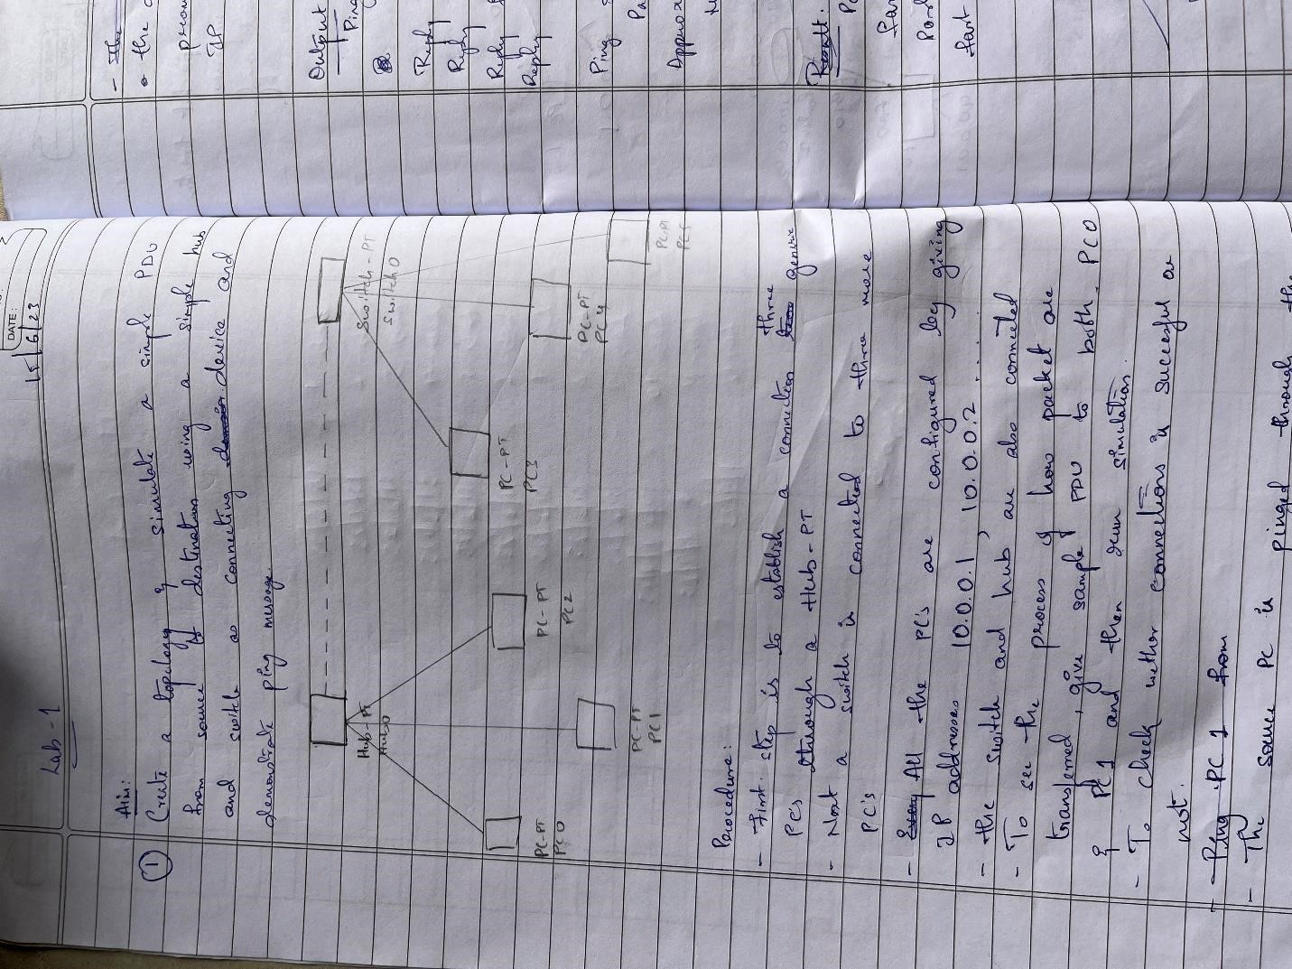

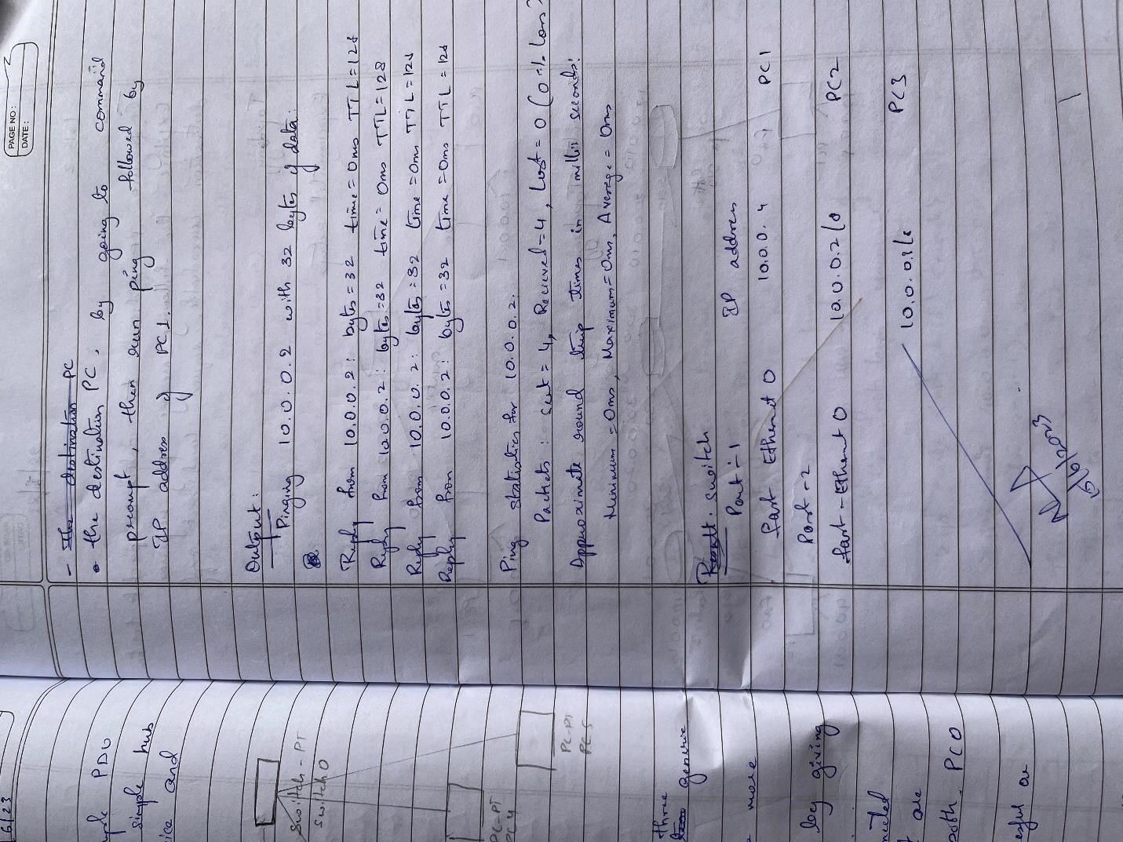

OUTPUT:

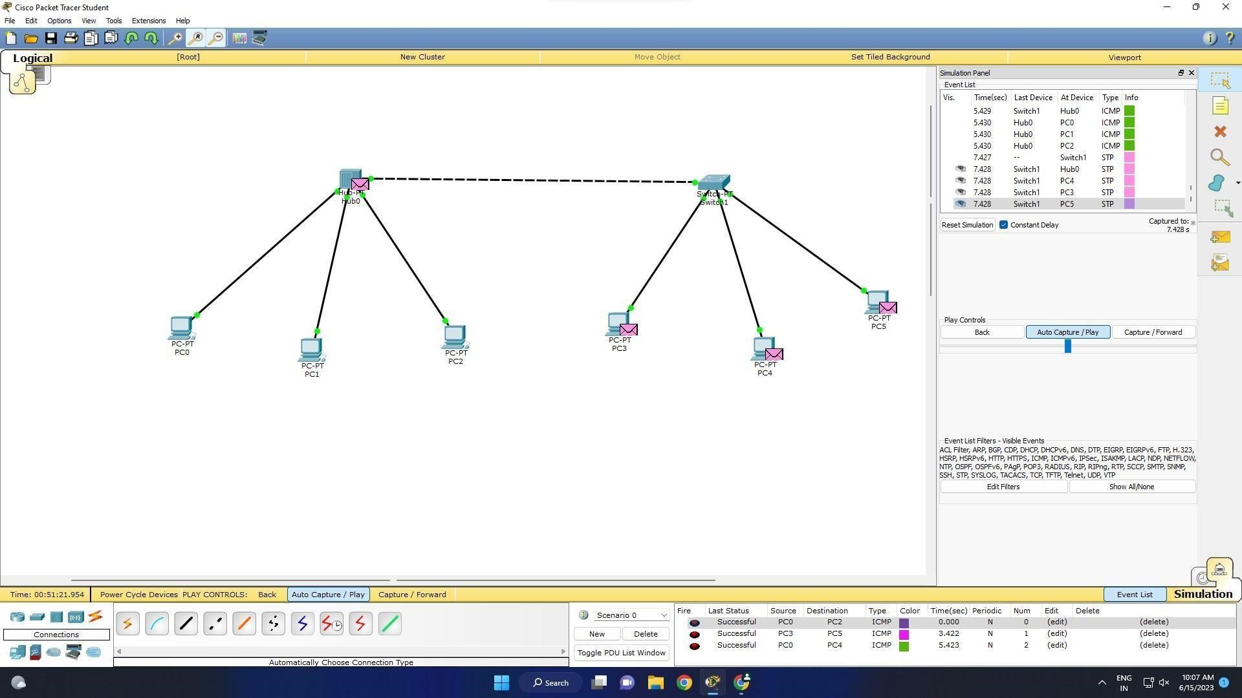 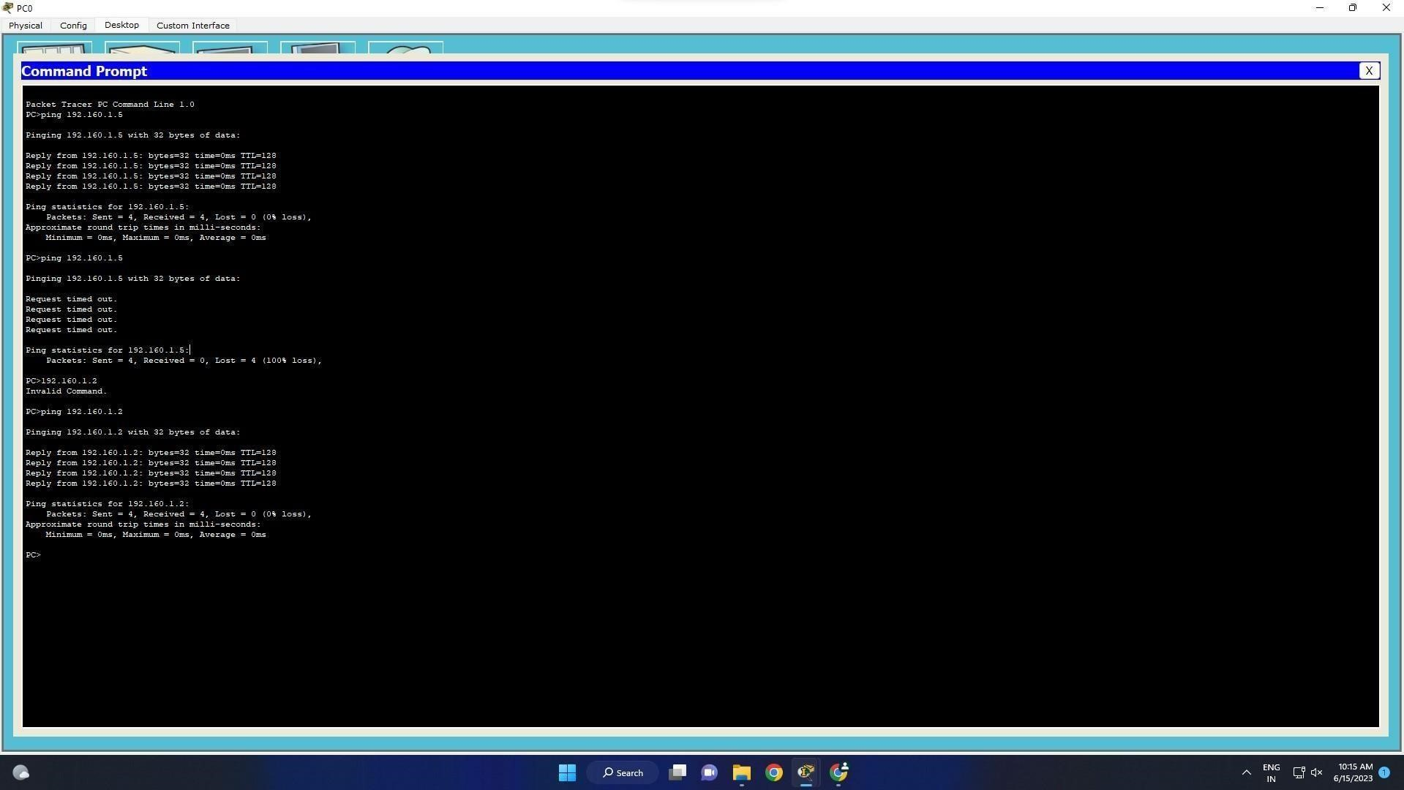

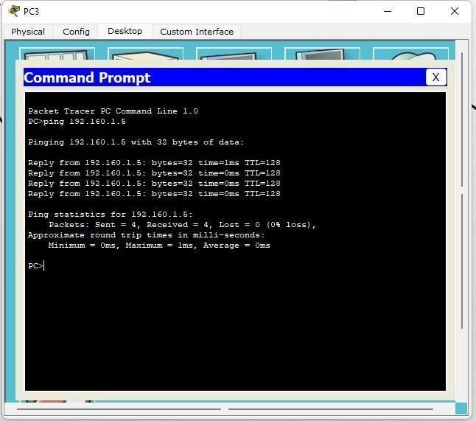

## LAB 2

Configure IP address to routers (one and three) in packet tracer. Explore the following messages: ping responses, destination unreachable, request timed out, reply.

OBSERVATION:

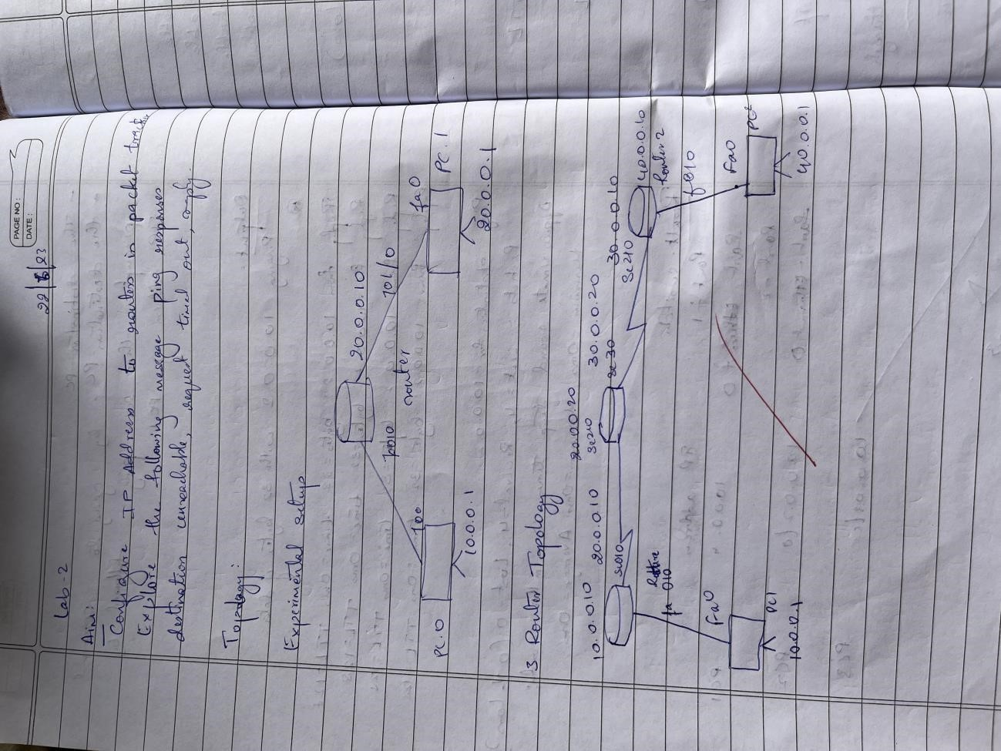

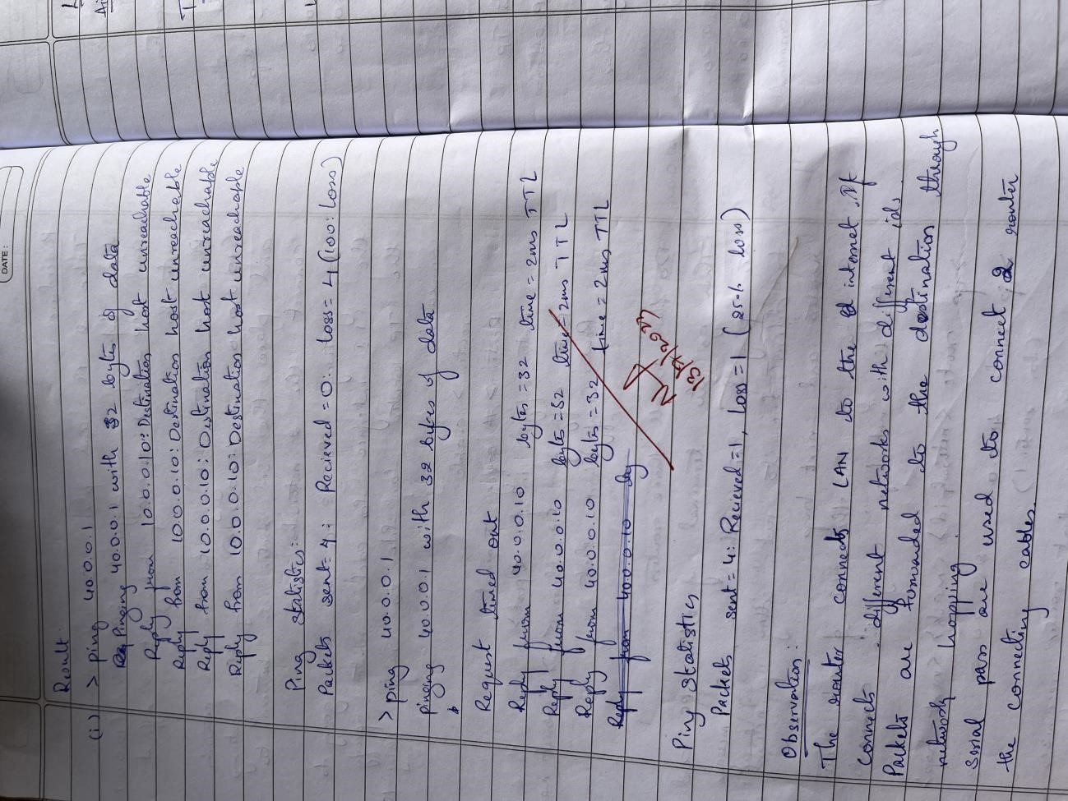

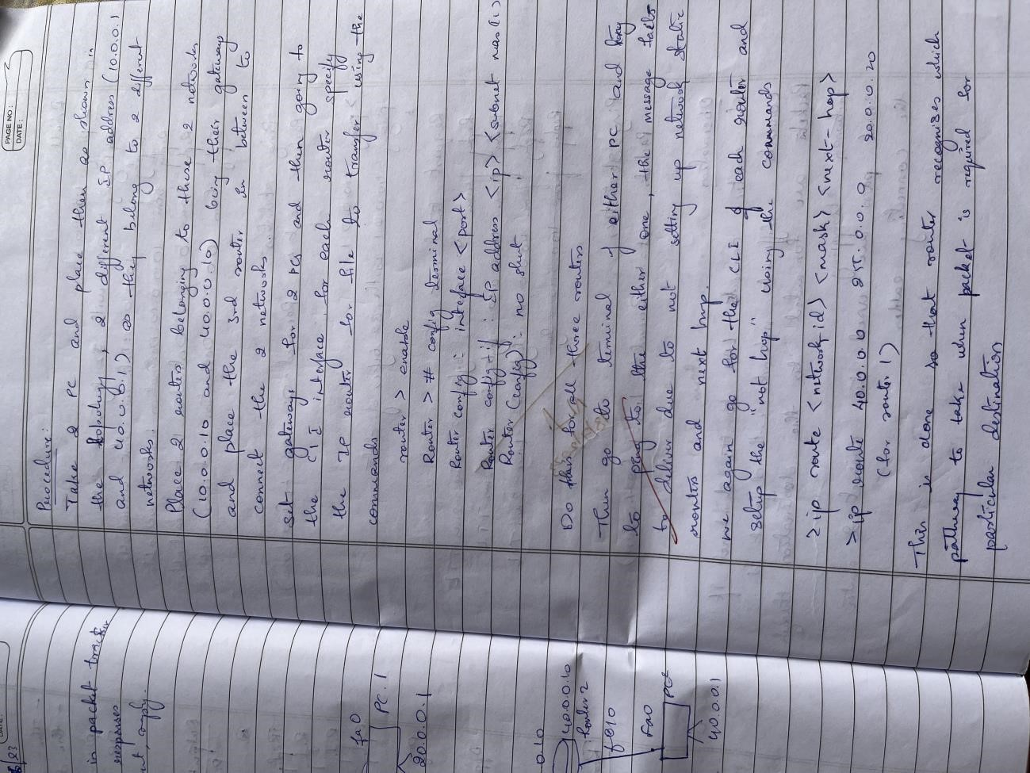

TOPOLOGY:

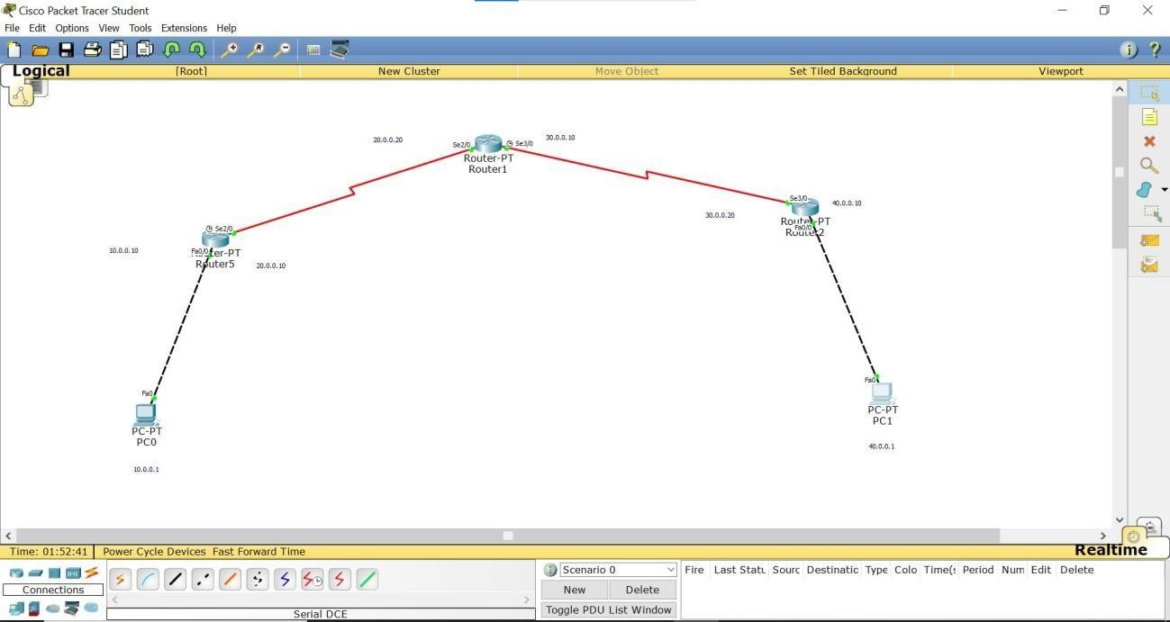

OUTPUT:

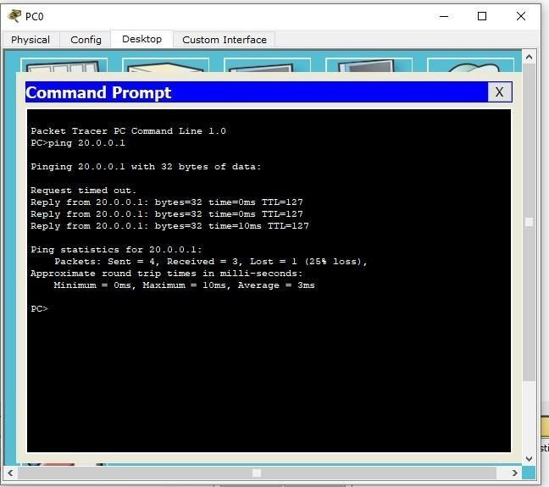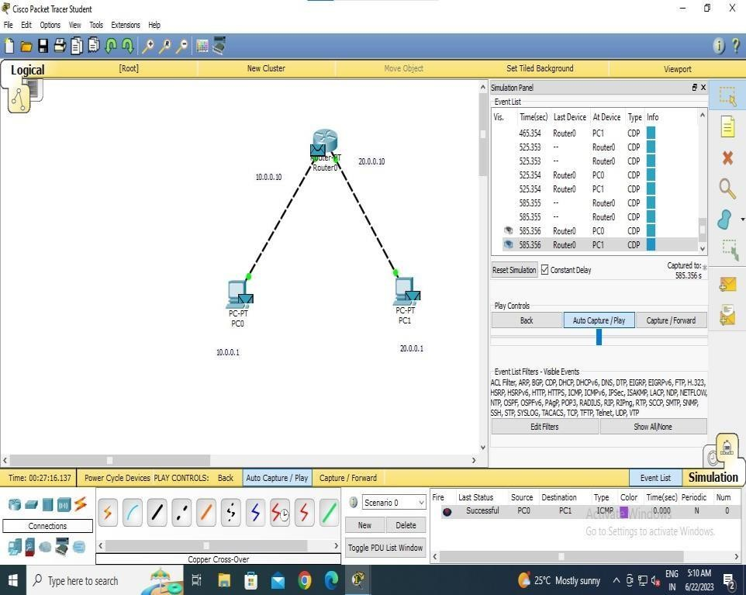

## LAB 3

Configure default route, static route to the Router.

OBSERVATION:

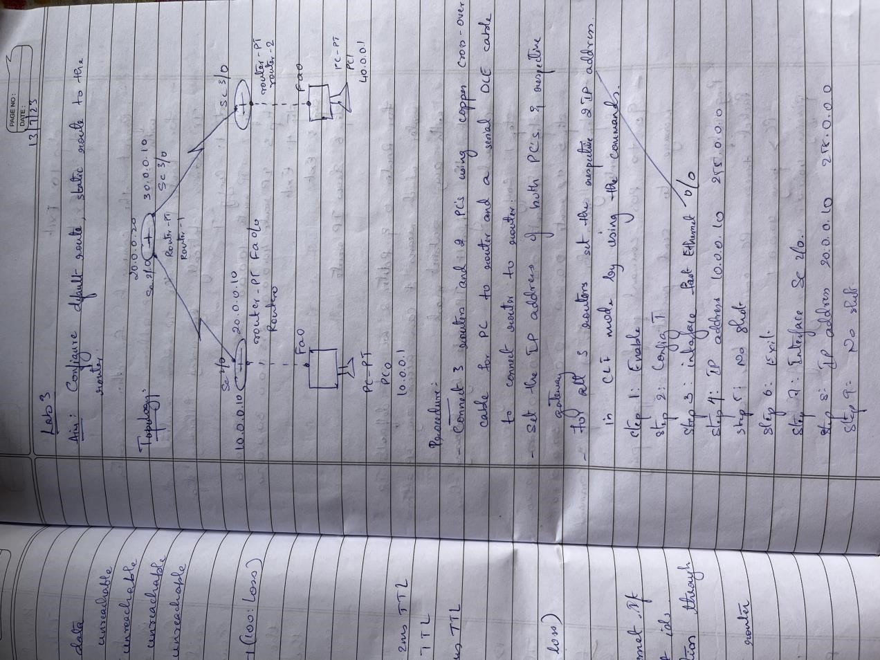

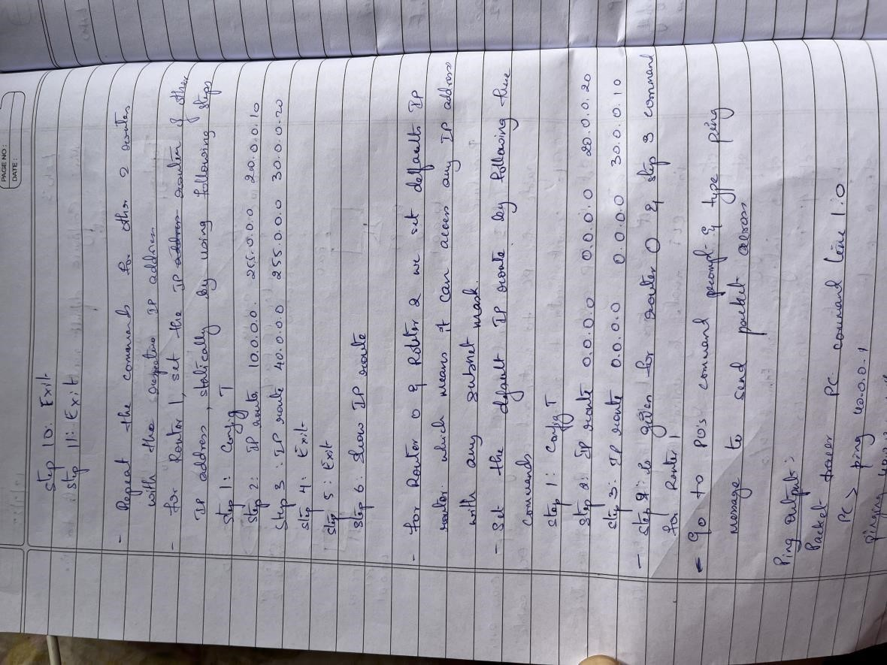

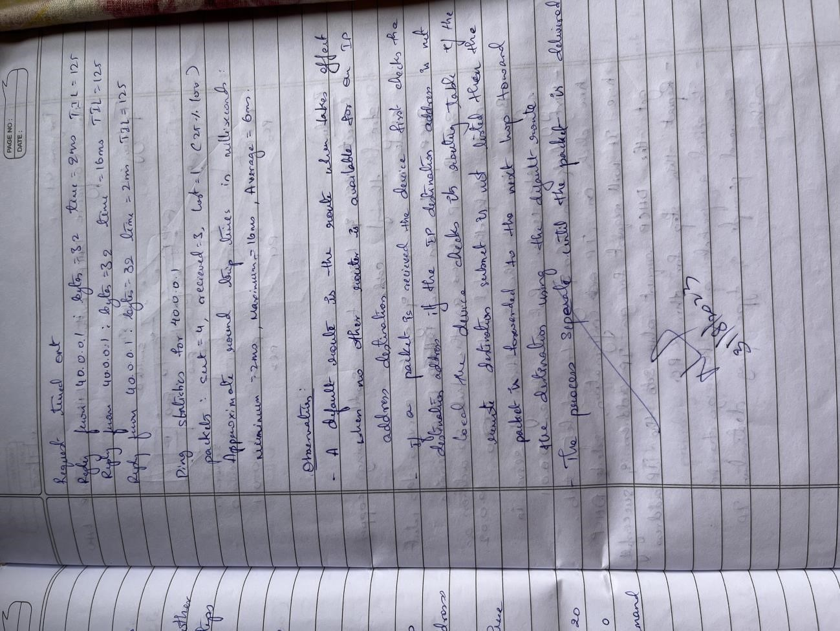

TOPOLOGY:

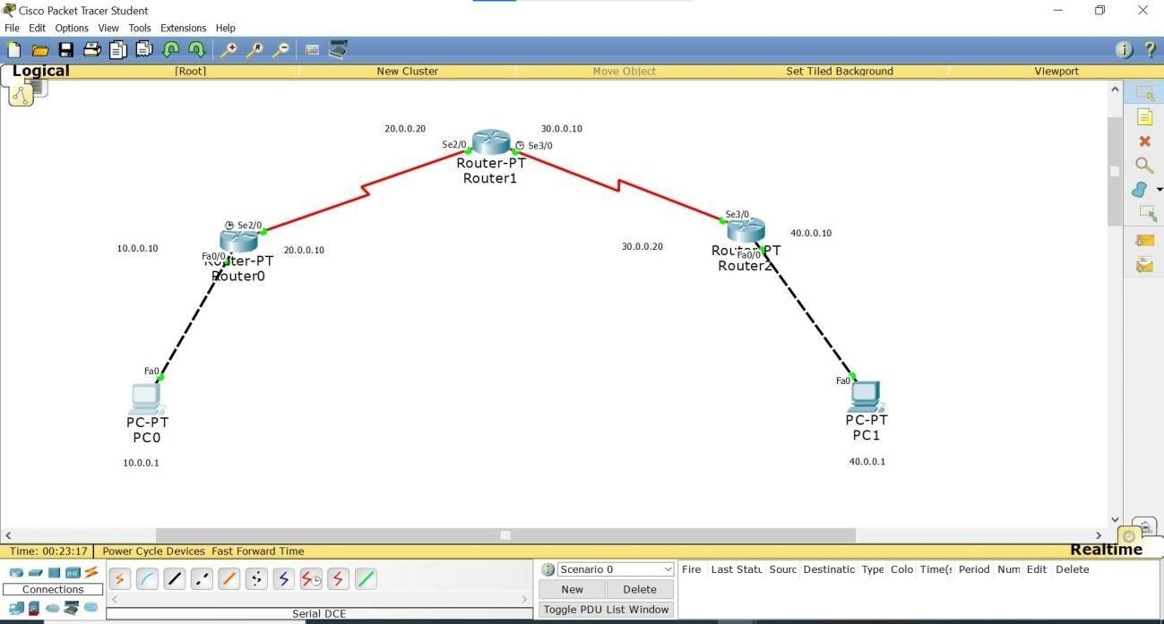

OUTPUT:

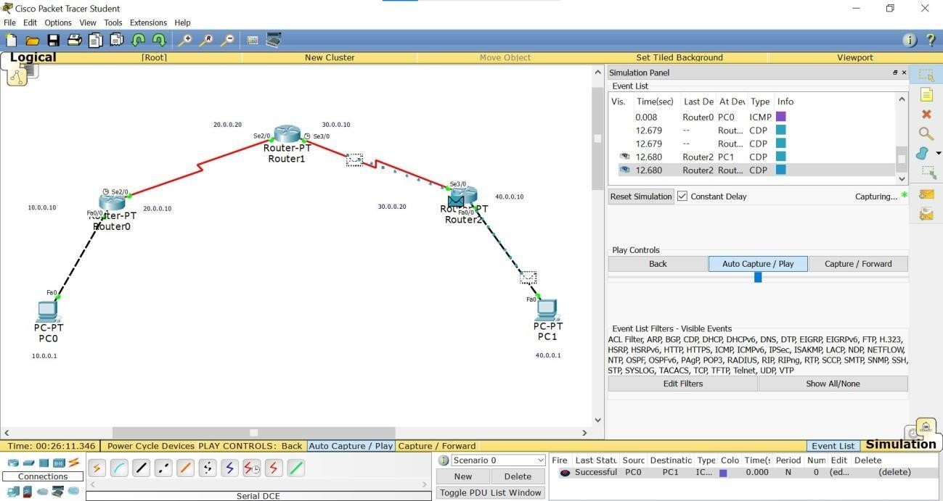

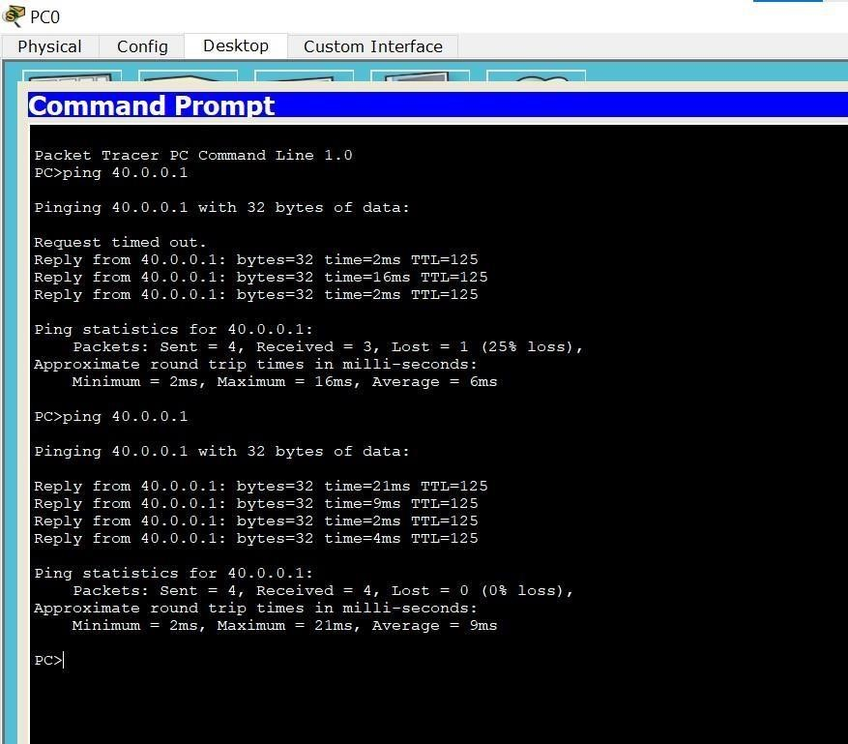

## LAB 4

Configure DHCP within a LAN and outside LAN.

OBSERVATION: TOPOLOGY:

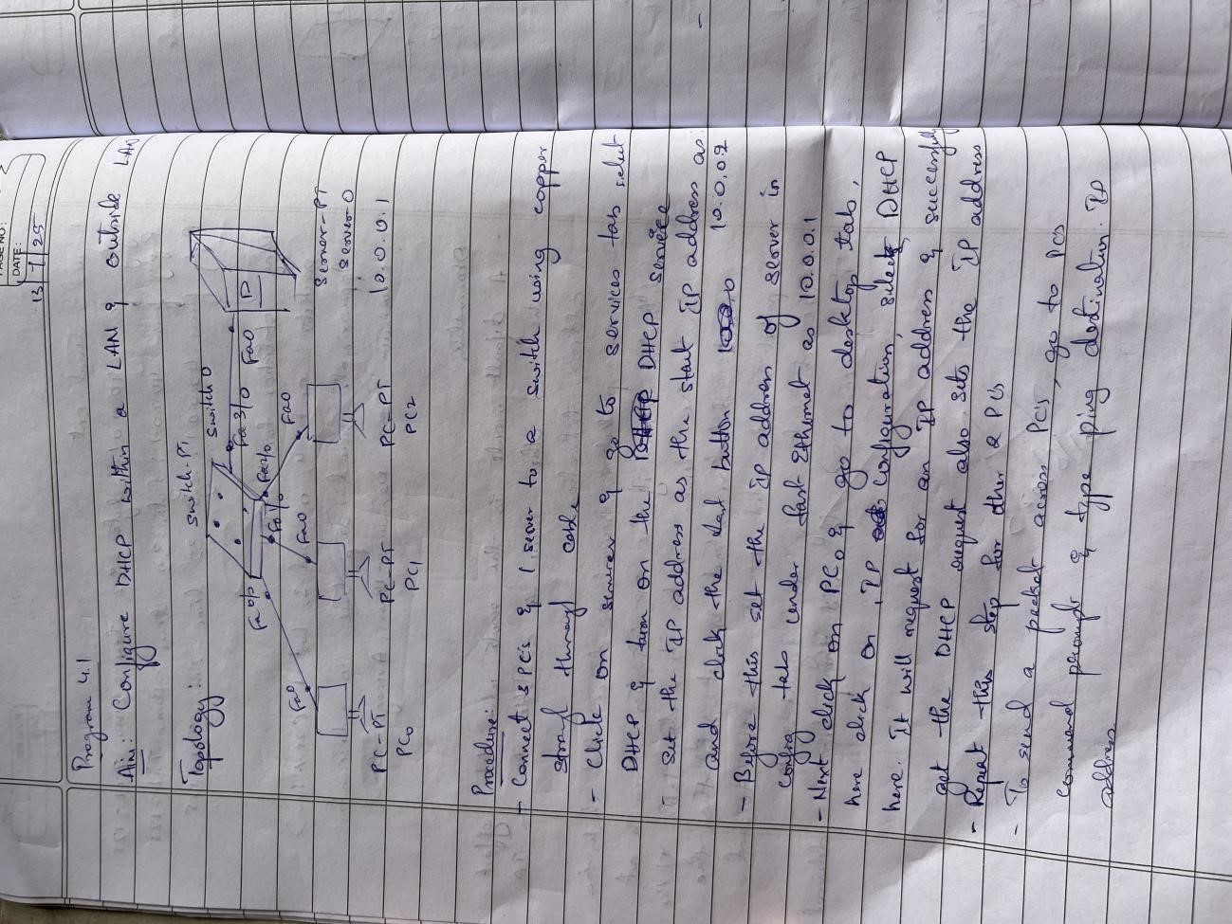

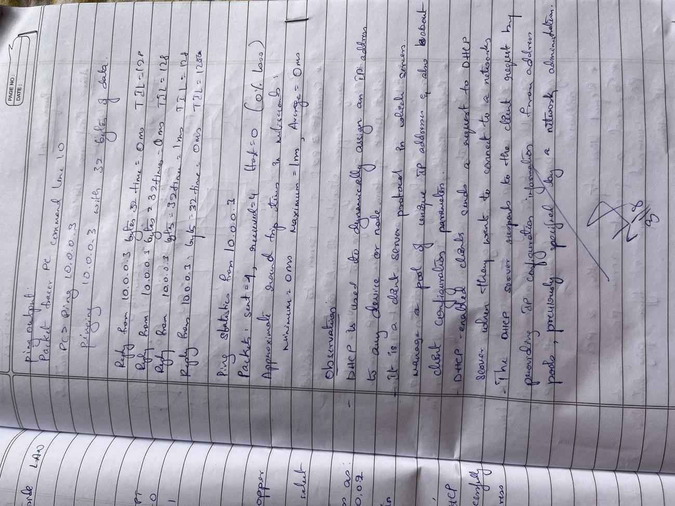

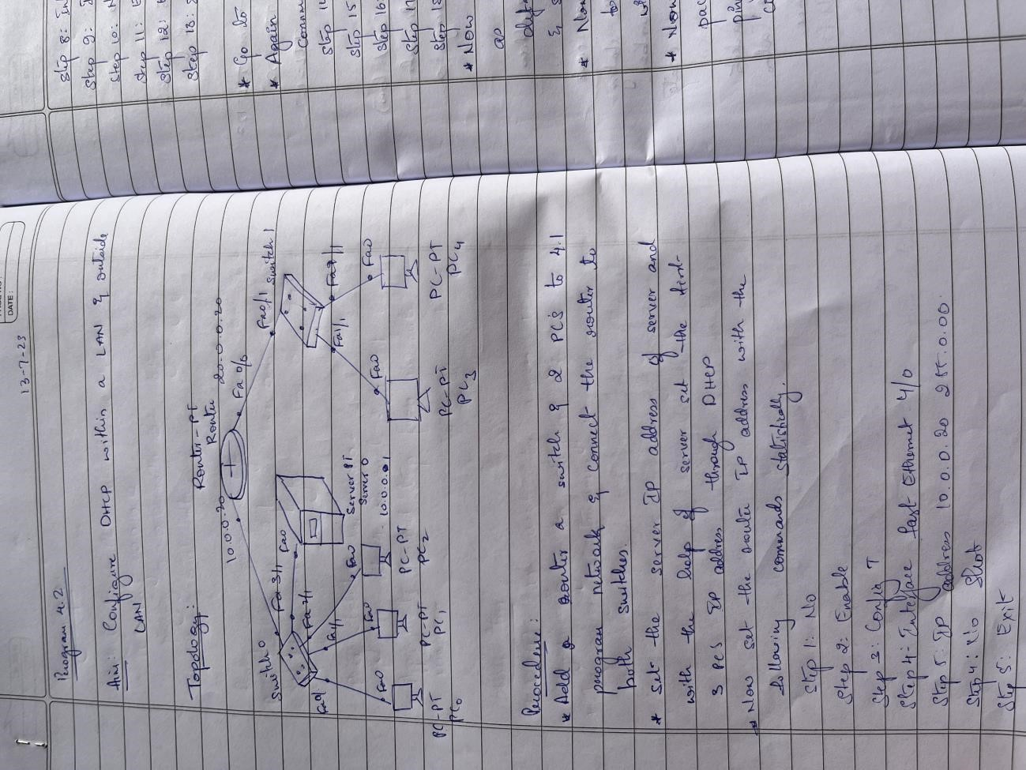

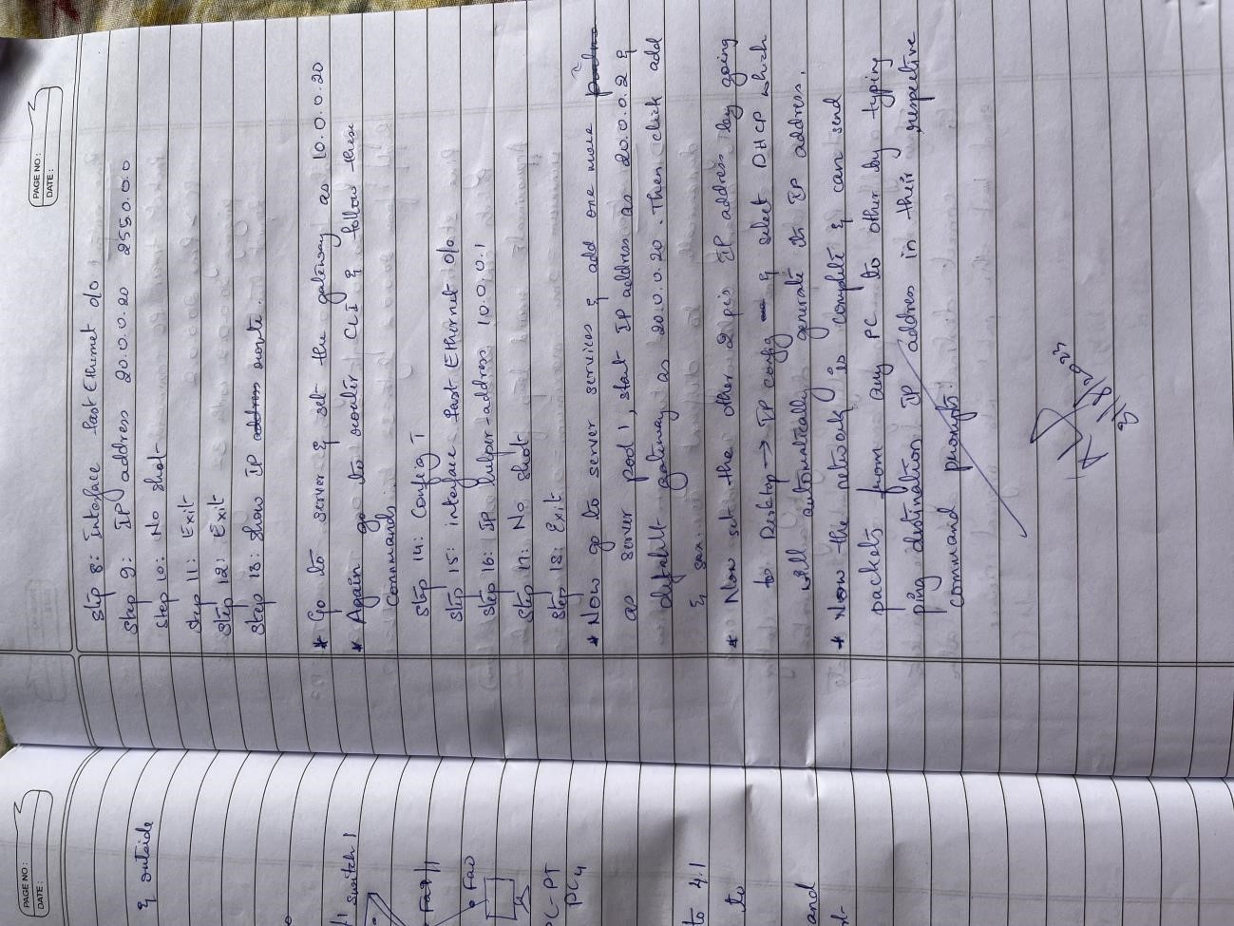

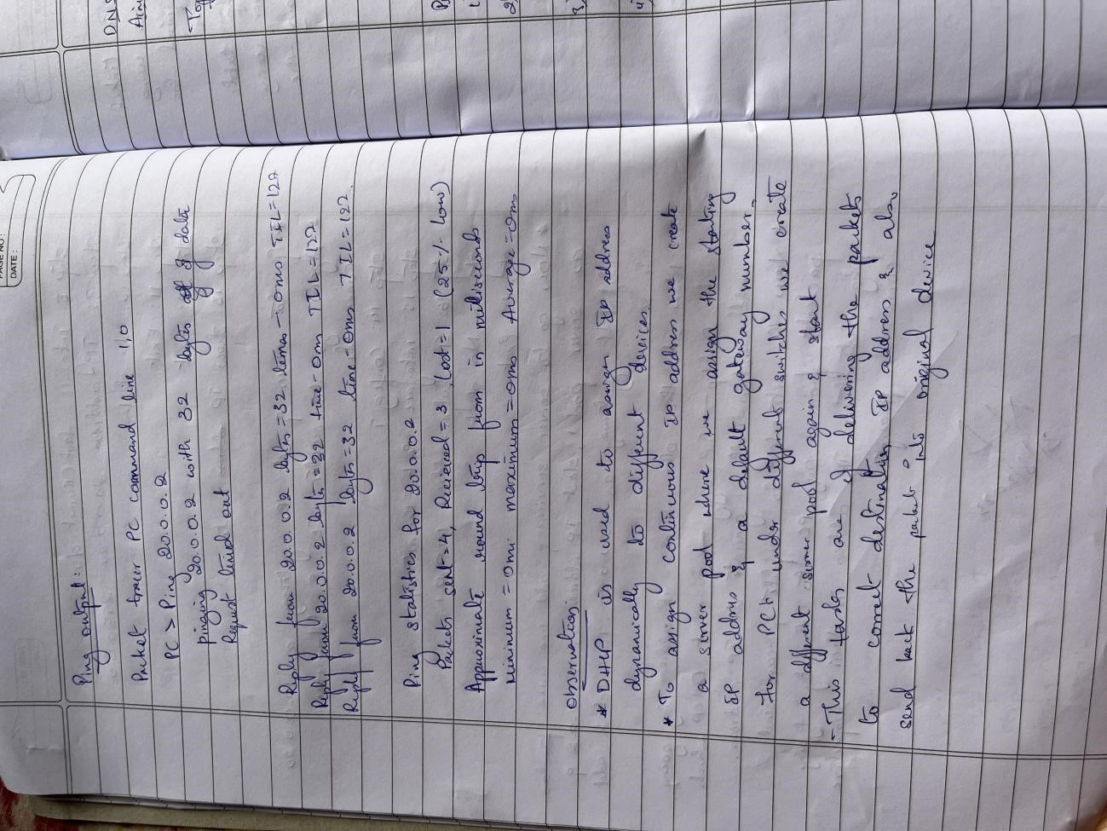

PROGRAM 4.1:

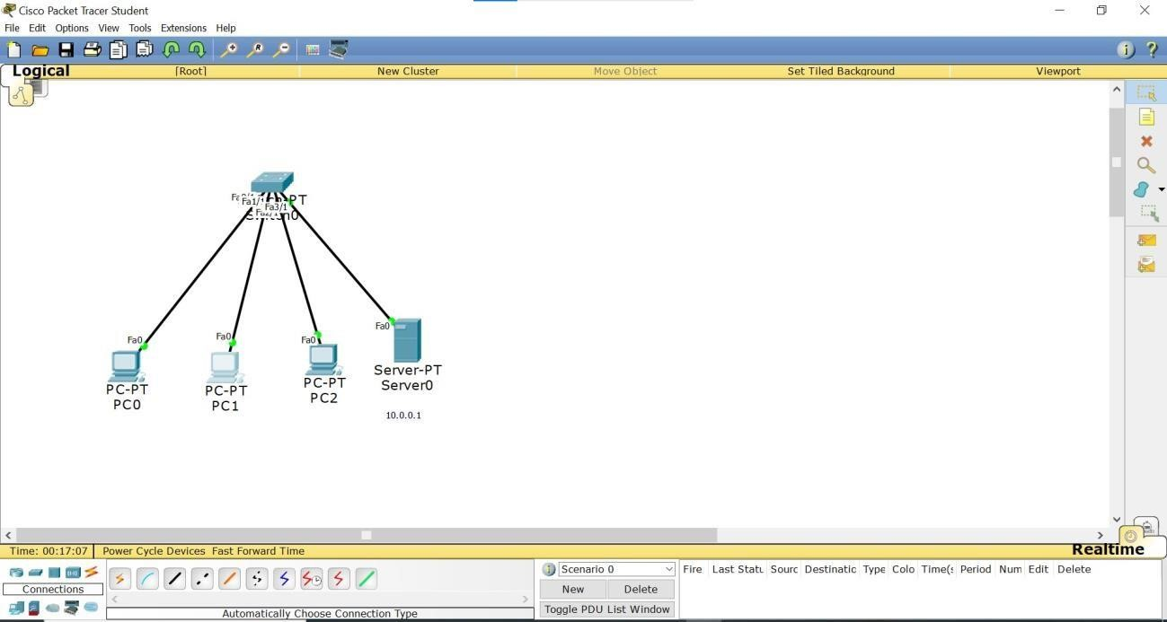

PROGRAM 4.2:

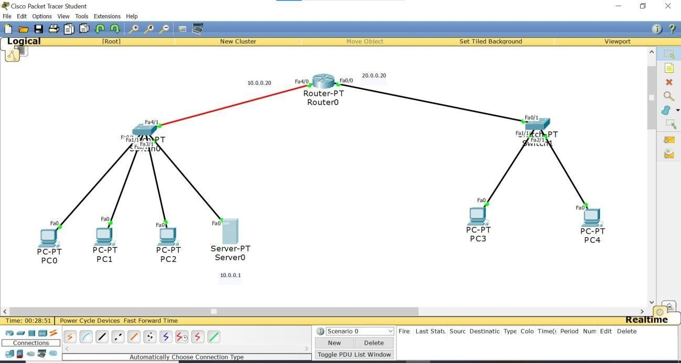

OUTPUT:

PROGRAM 4.1:

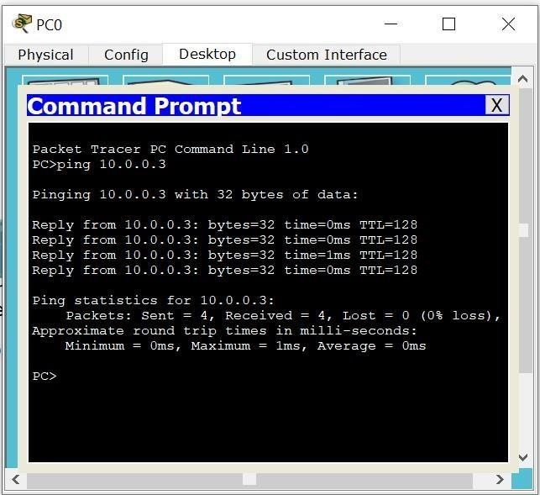

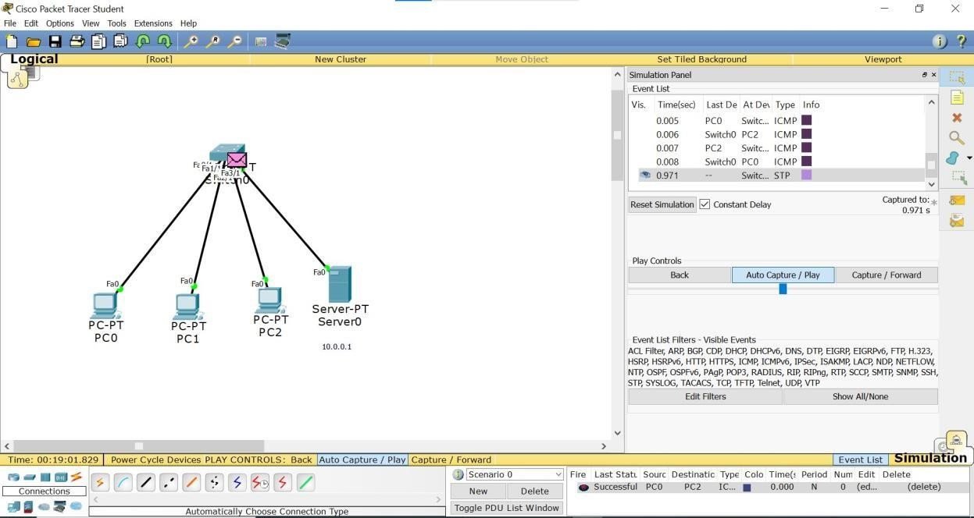

PROGRAM 4.2:

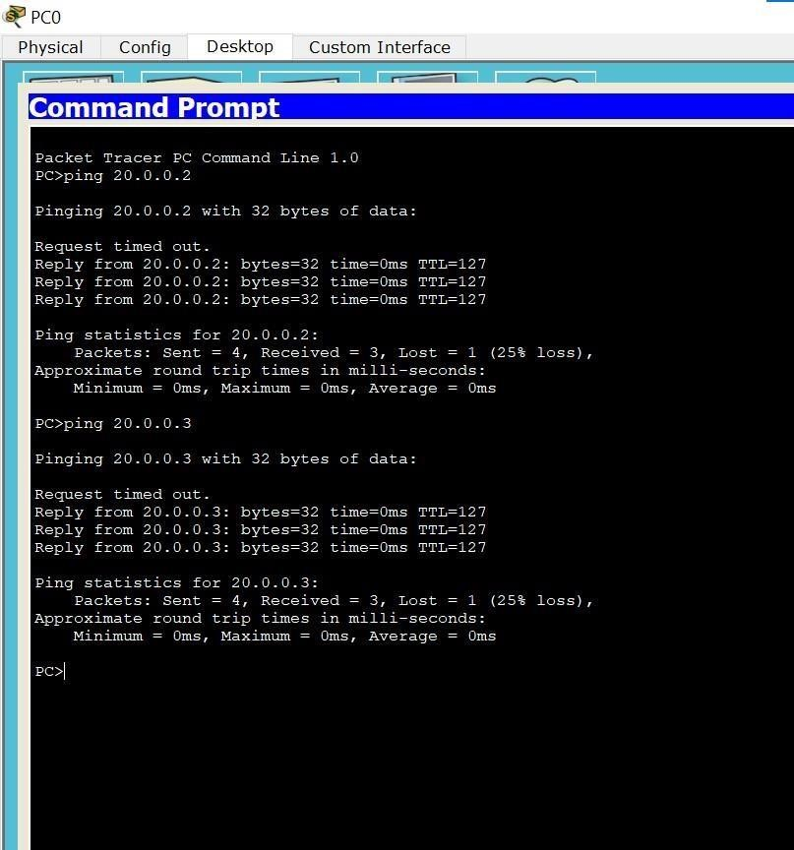

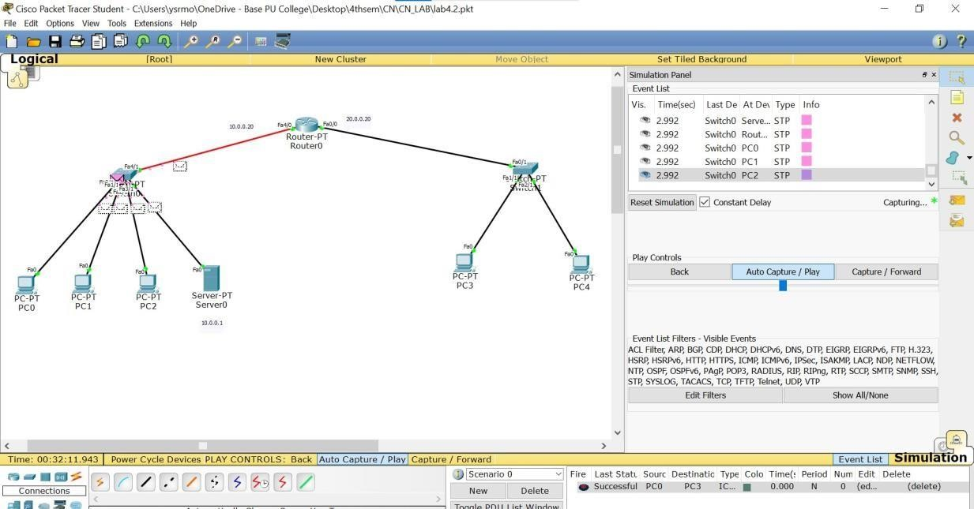

## WEEK5

Configure Web Server, DNS within a LAN.

OBSERVATION:

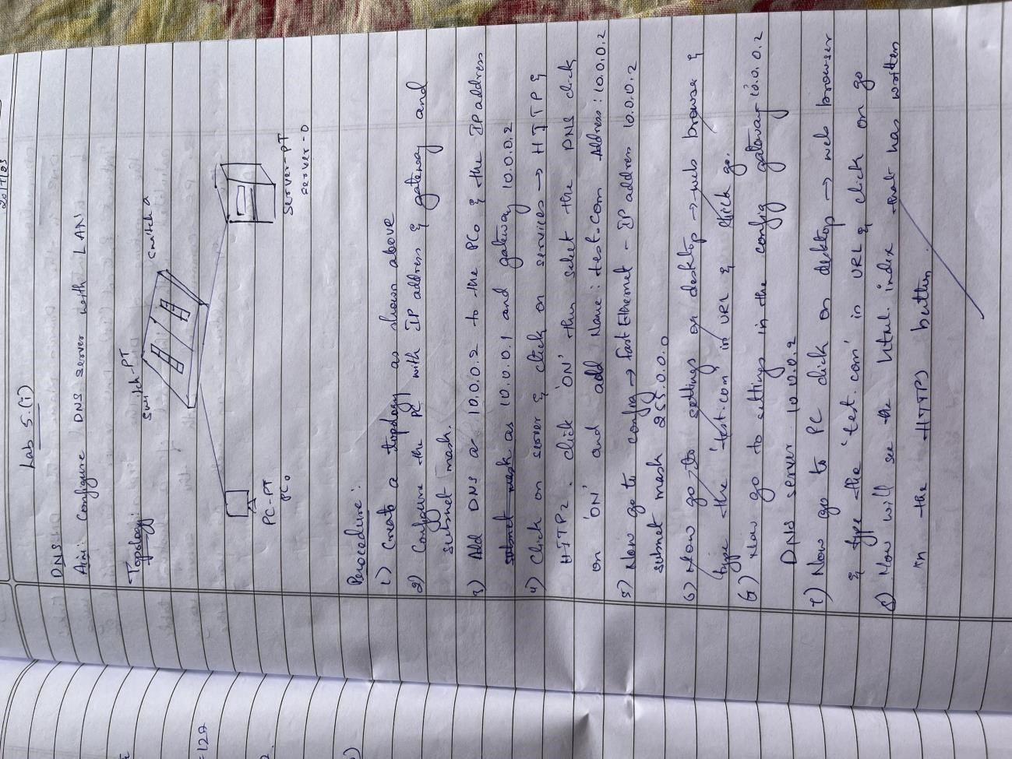

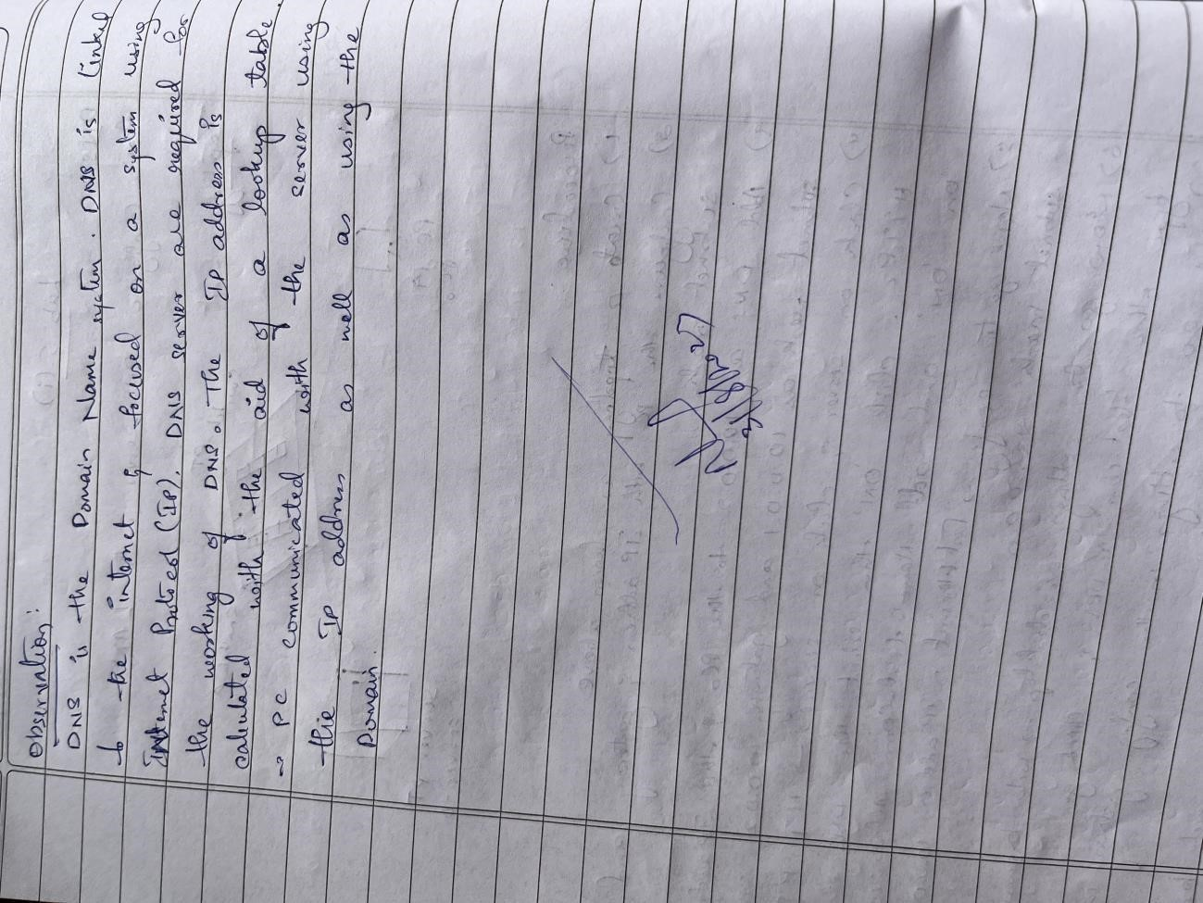

TOPOLOGY:

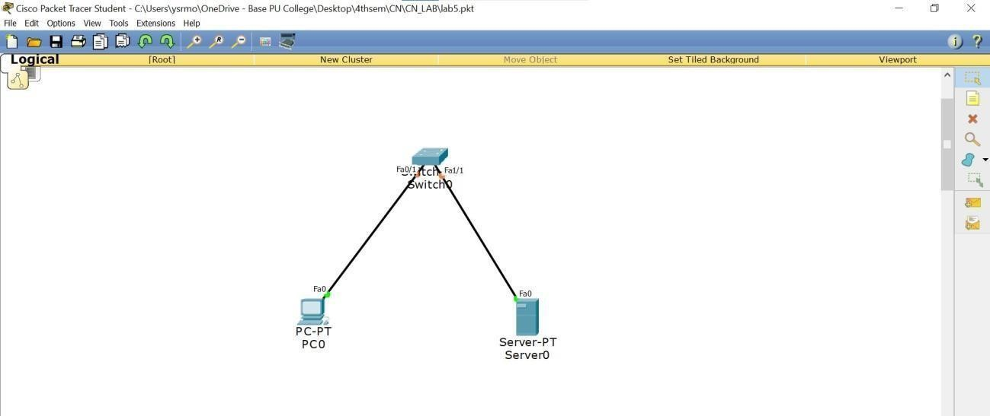

## LAB 6

Configure RIP routing Protocol in Routers.

OBSERVATION:

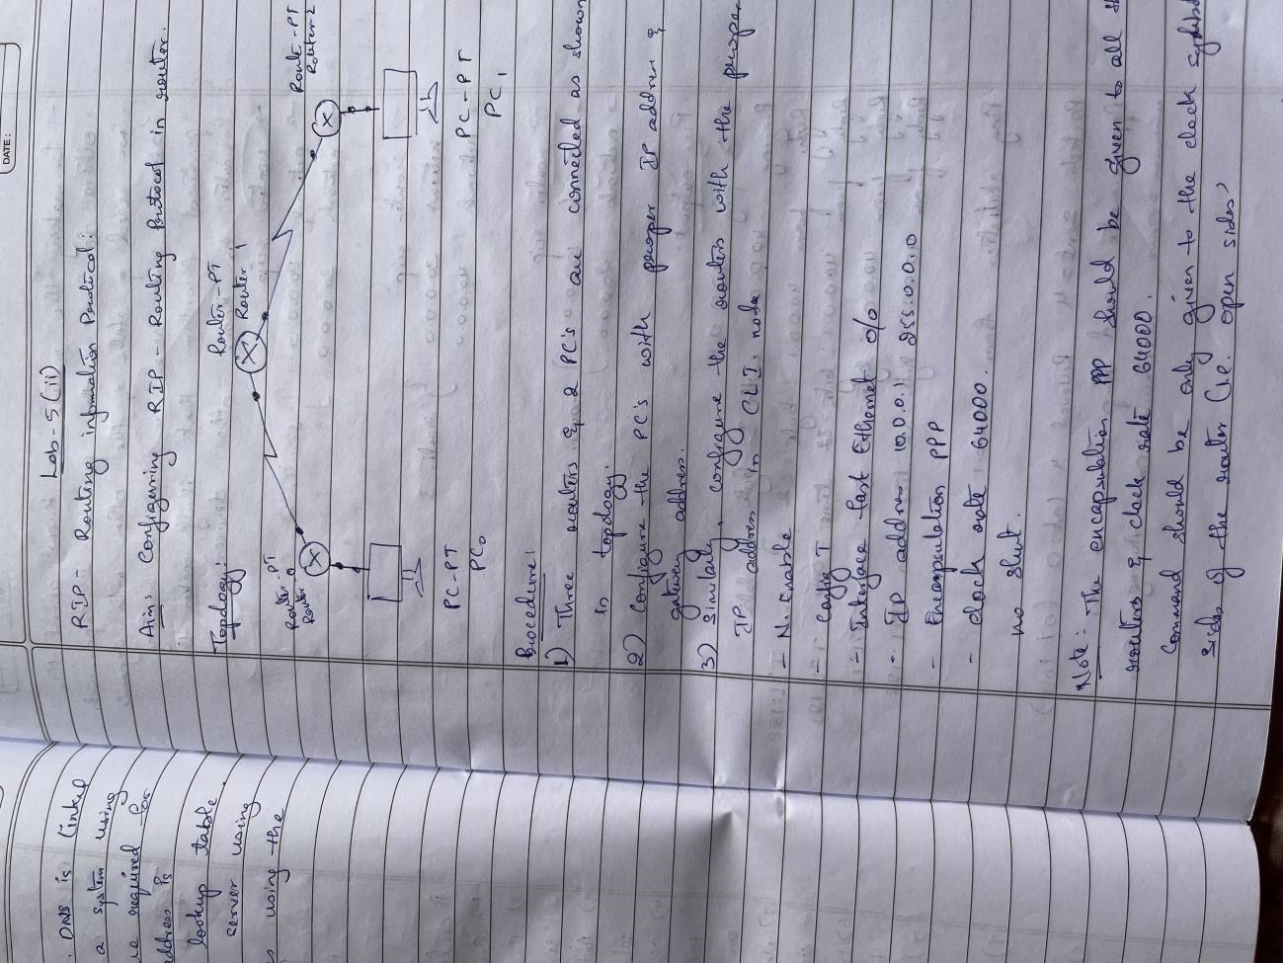

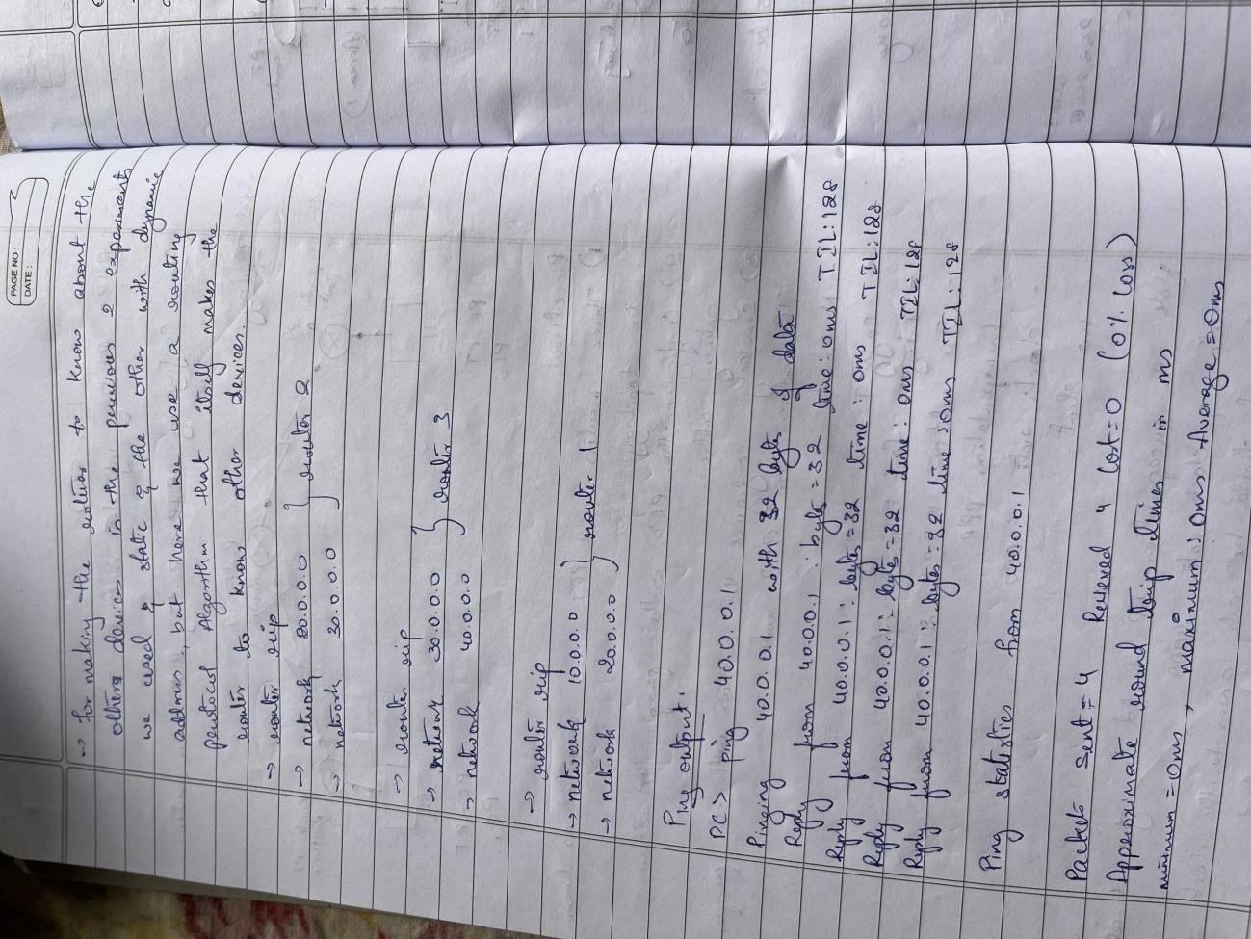

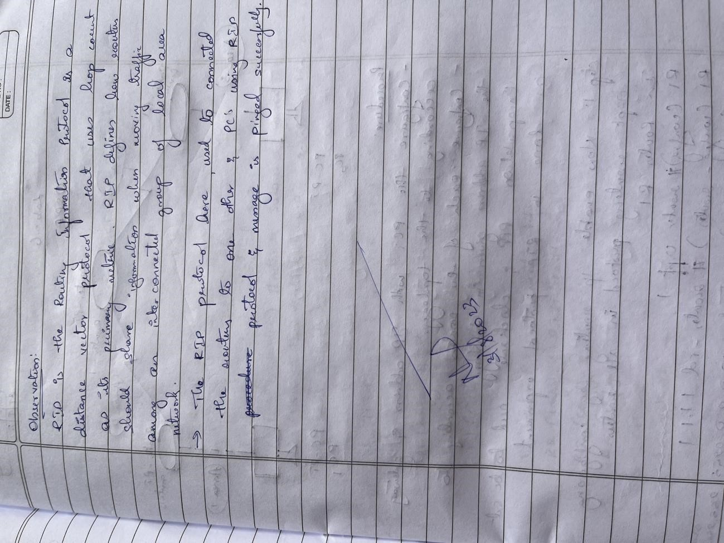

TOPOLOGY:

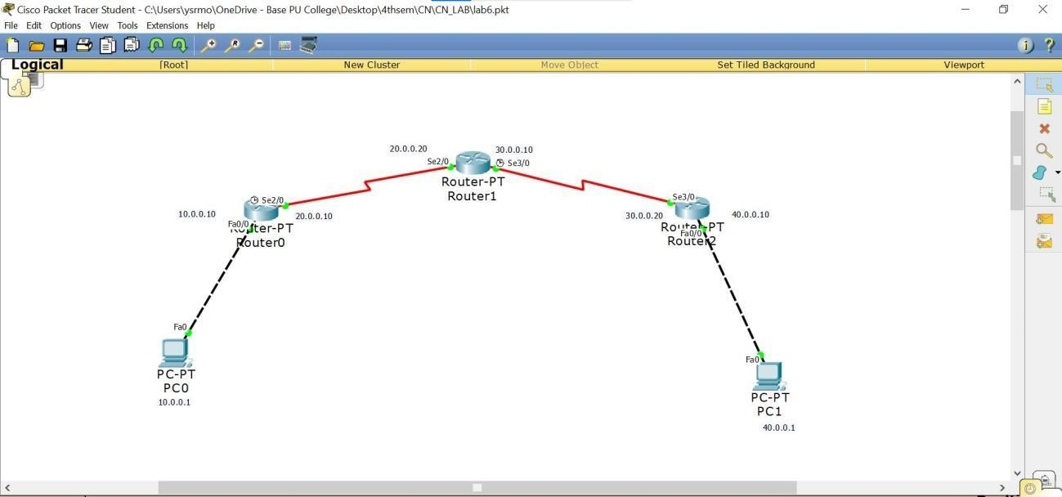

OUTPUT:

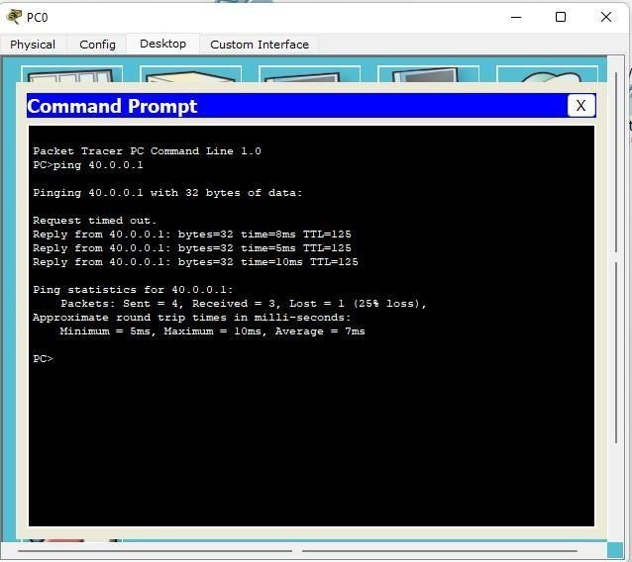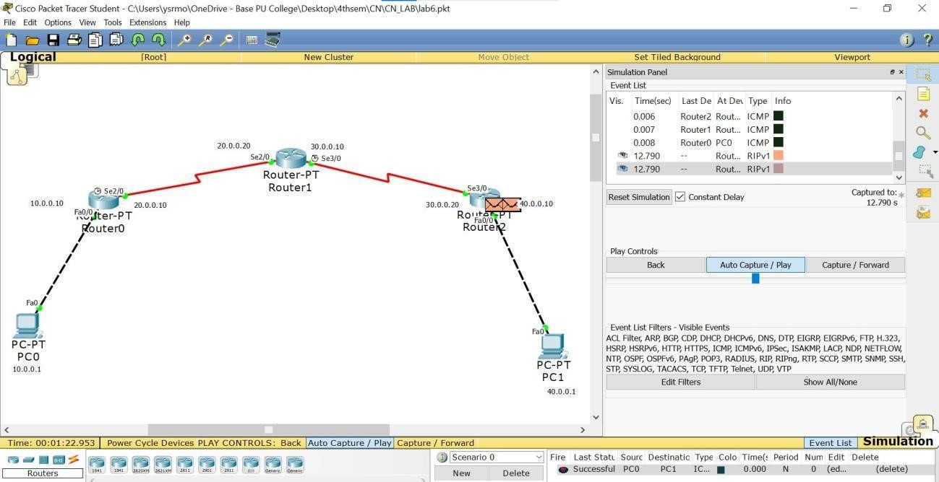

## LAB 7

Configure OSPF routing protocol.

OBSERVATION:

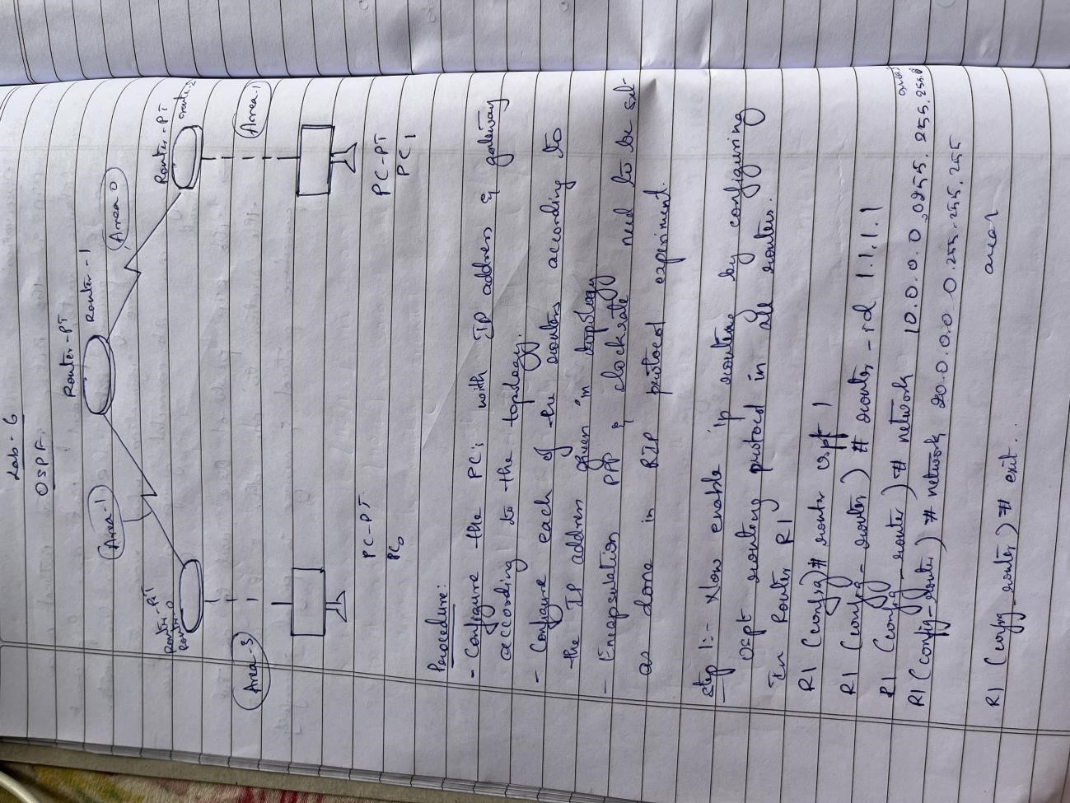

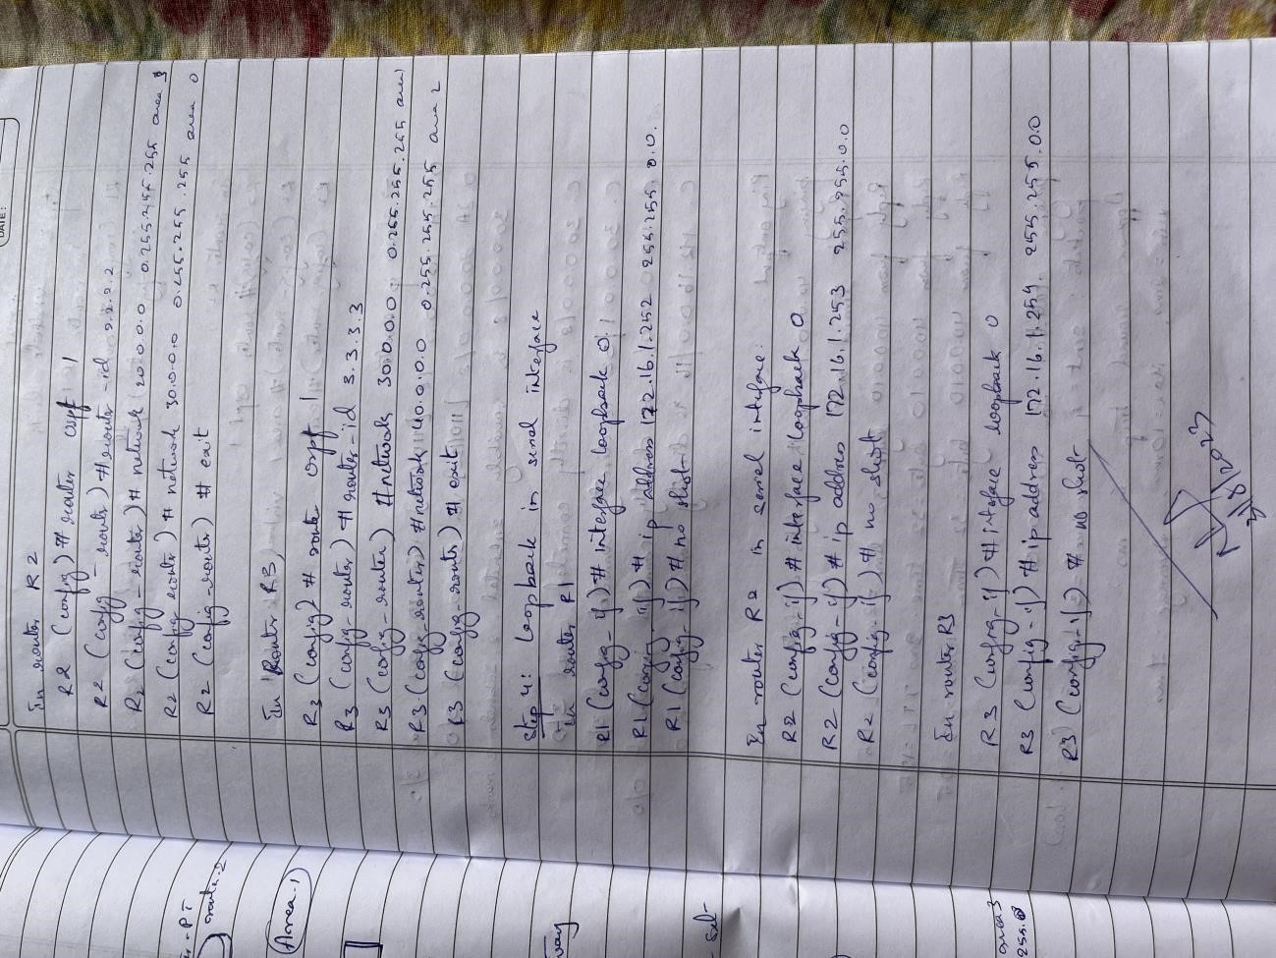

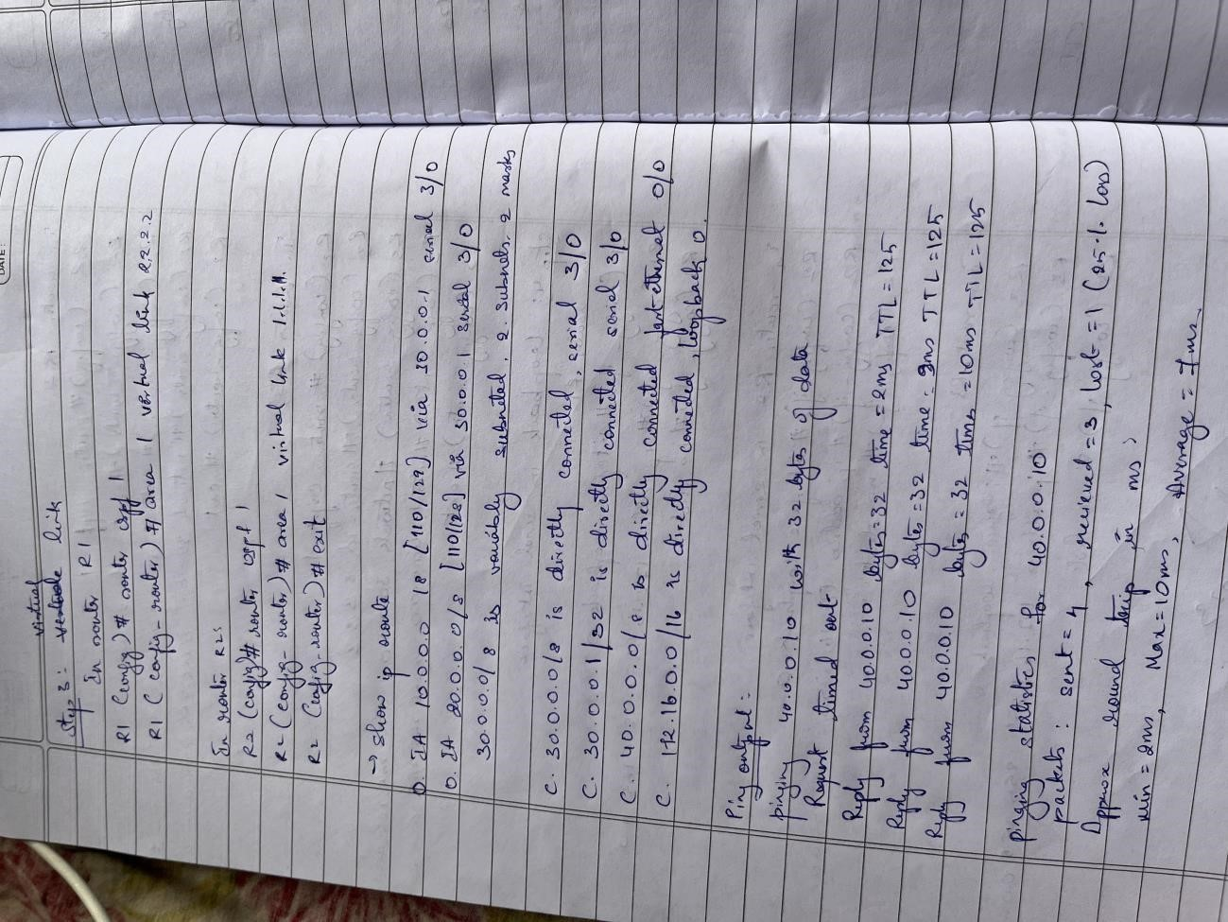

TOPOLOGY:

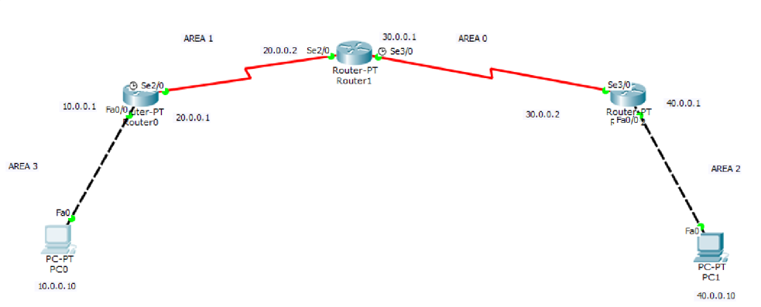

OUTPUT:

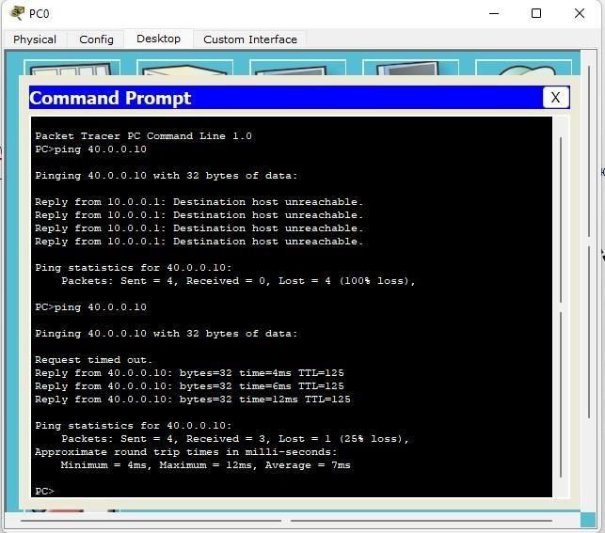

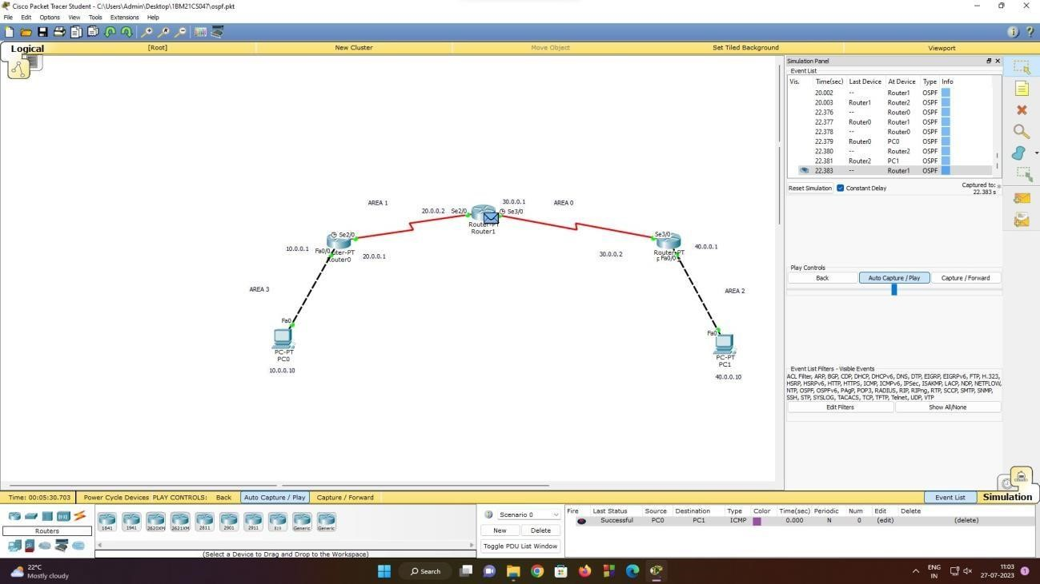

## LAB 8

To construct a simple LAN and understand the concept and operation of Address Resolution Protocol (ARP).

OBSERVATION:

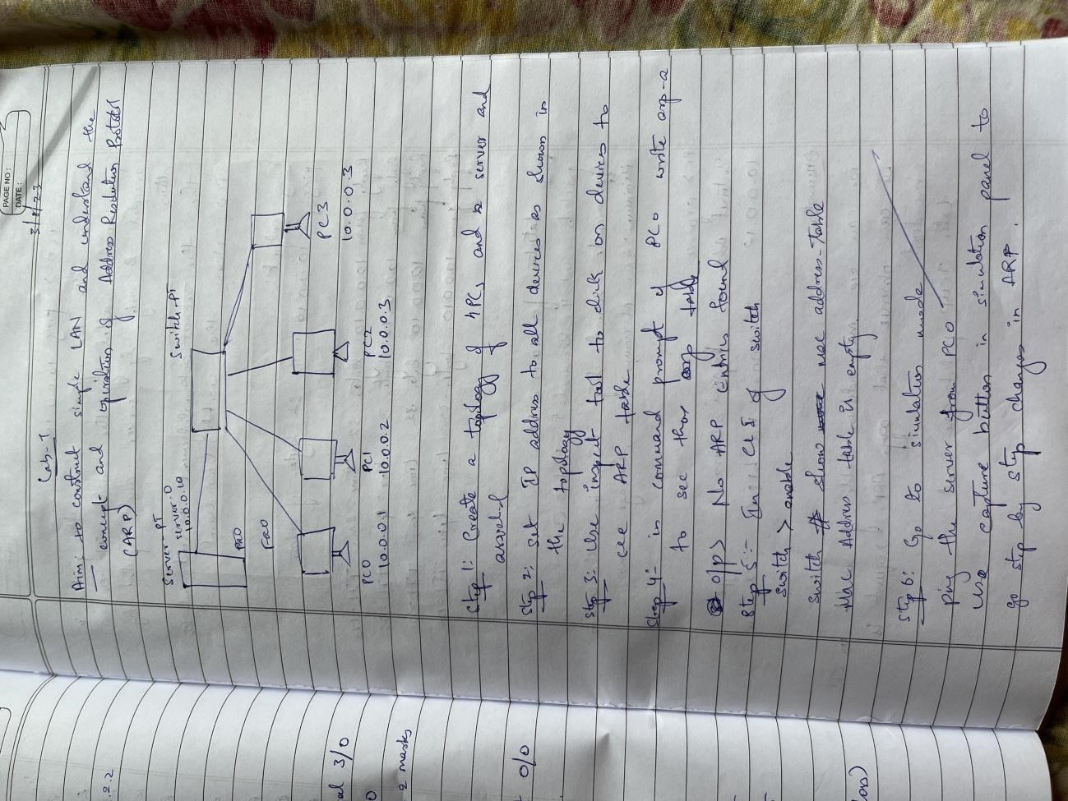

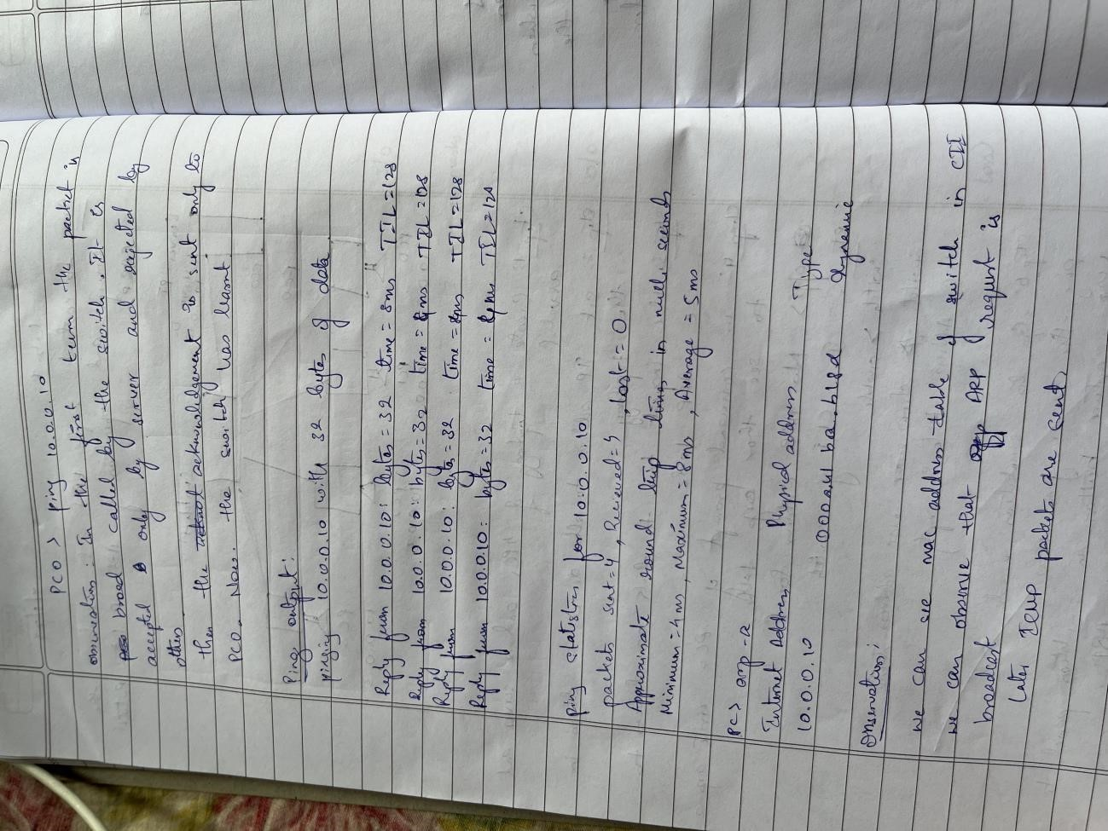

TOPOLOGY:

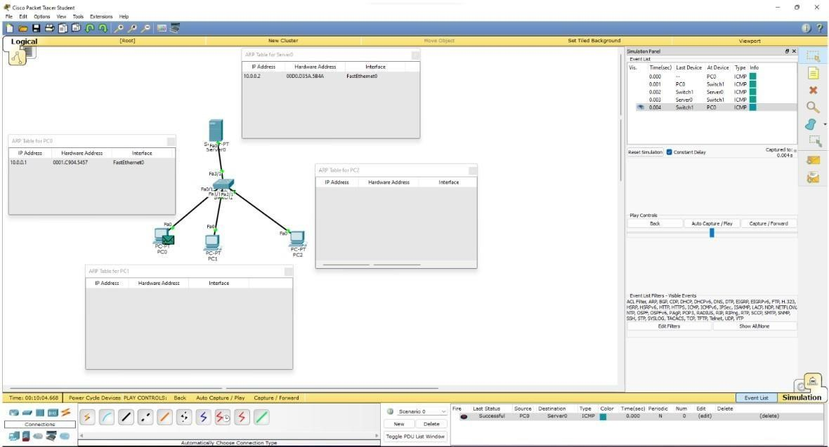

OUTPUT:

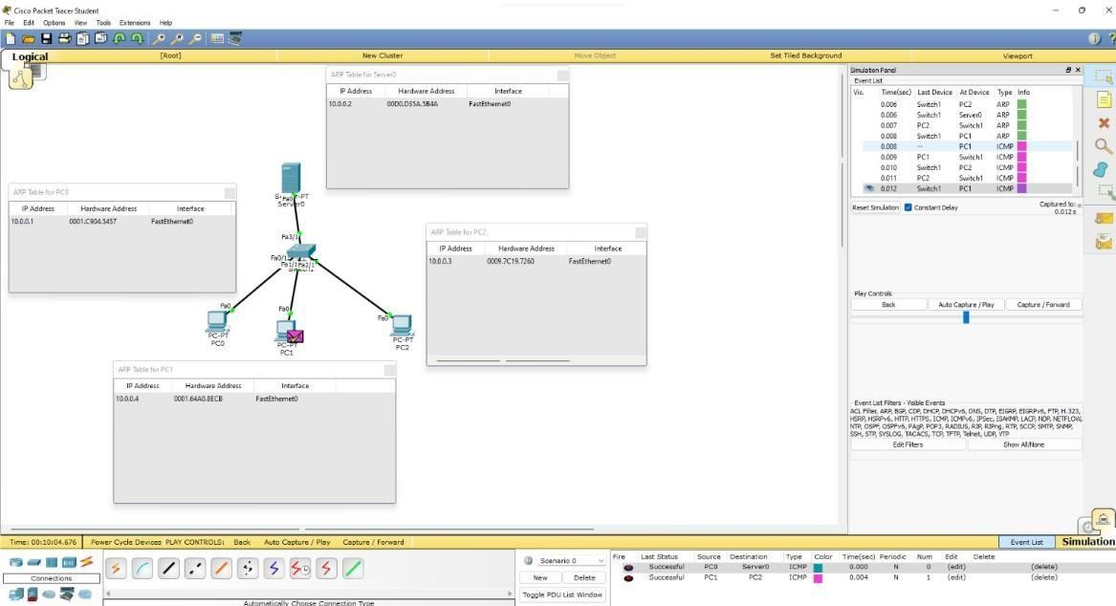

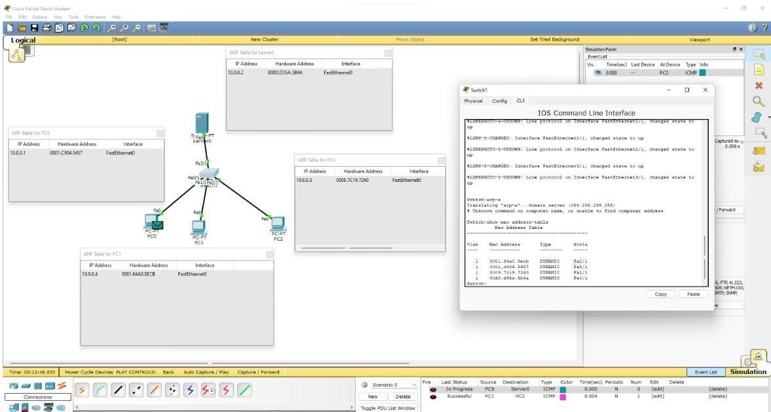

## LAB 9

To construct a VLAN and make a pc communicate among VLAN.

OBSERVATION:

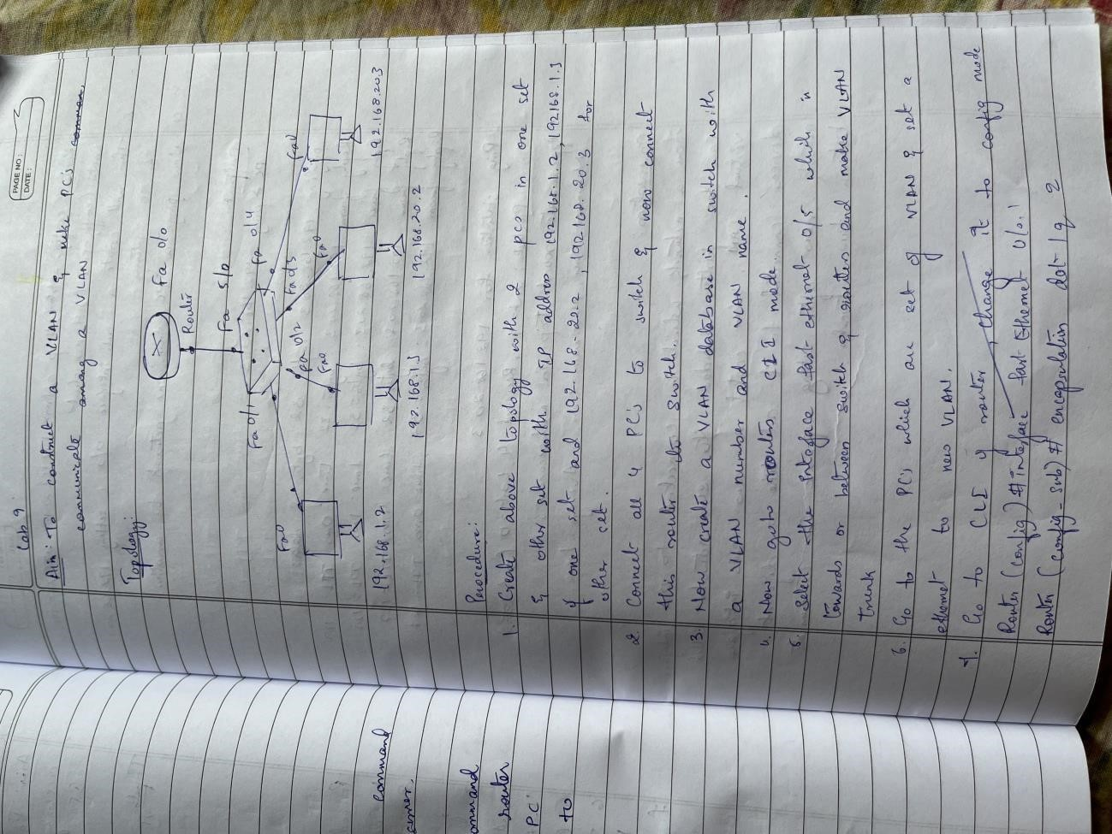

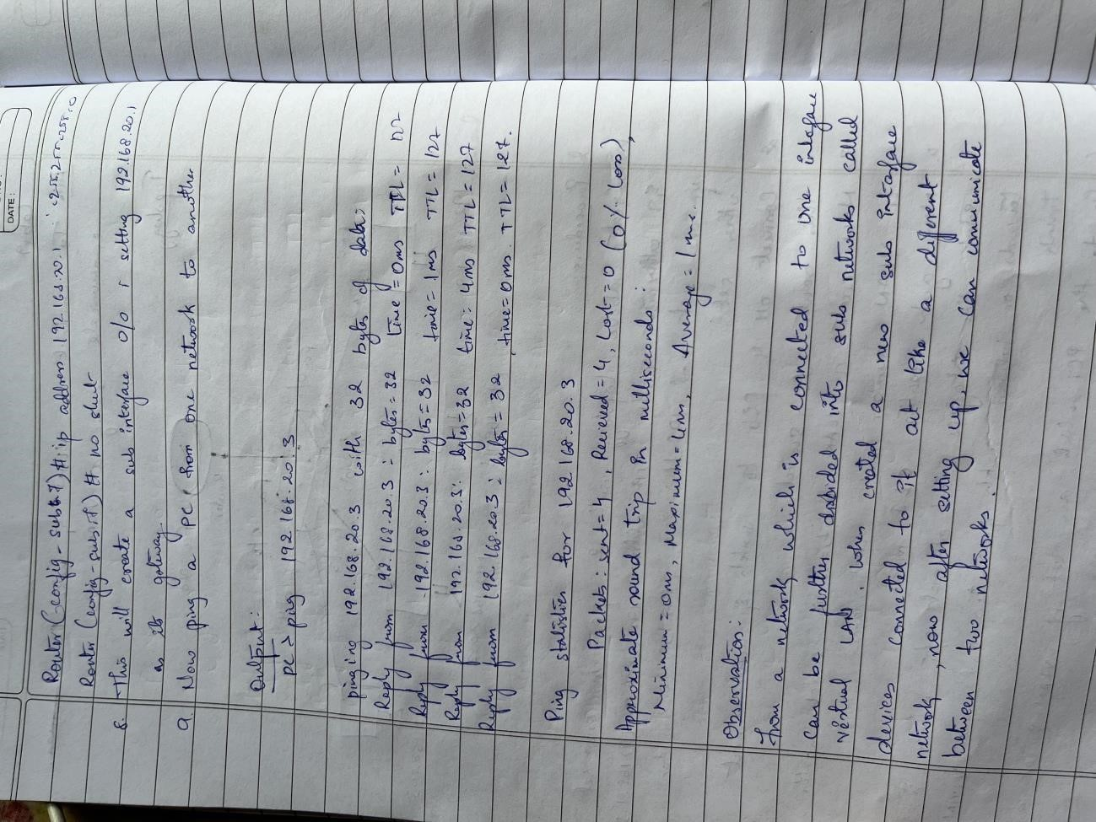

TOPOLOGY:

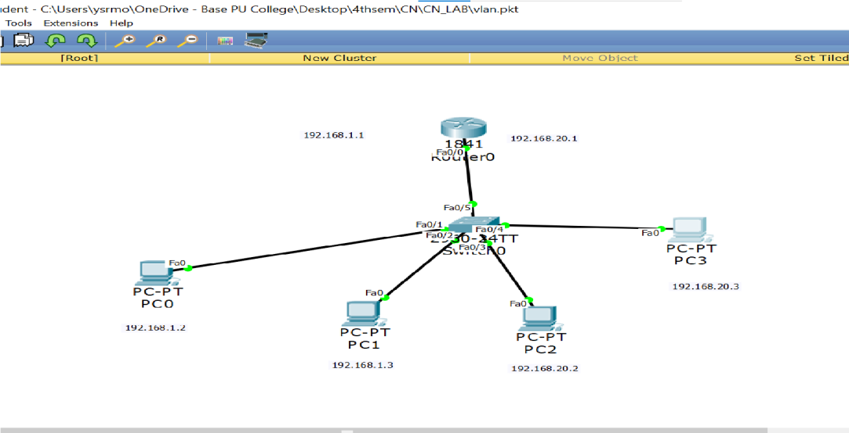

OUTPUT:

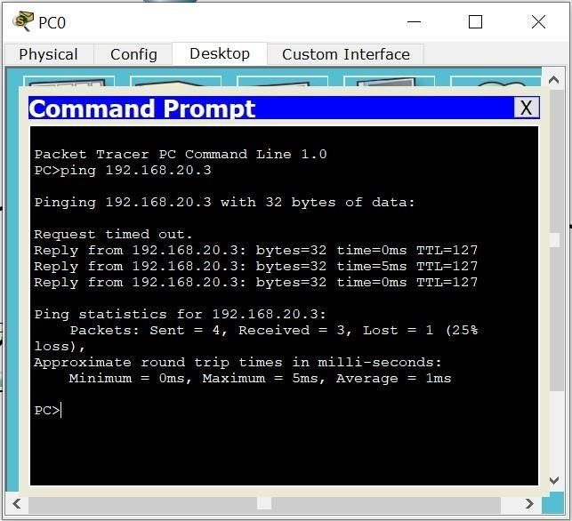

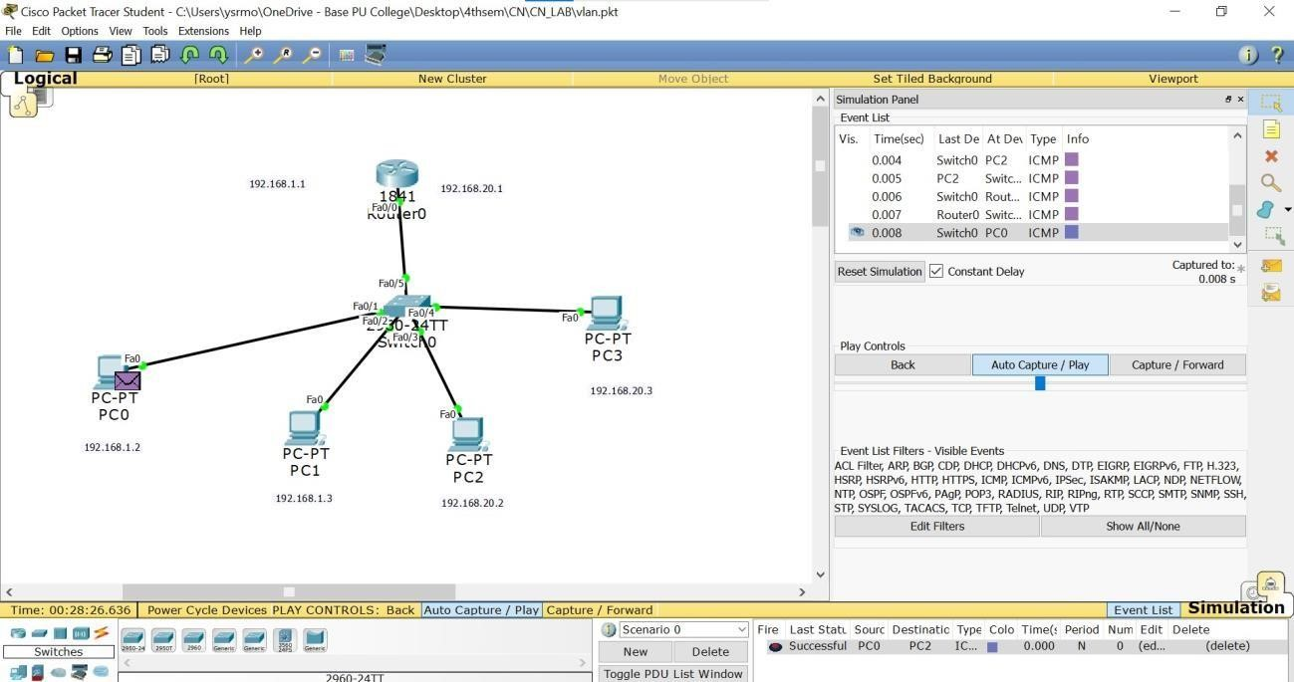

## LAB 10

Demonstrate the TTL/ Life of a Packet.

OBSERVATION:

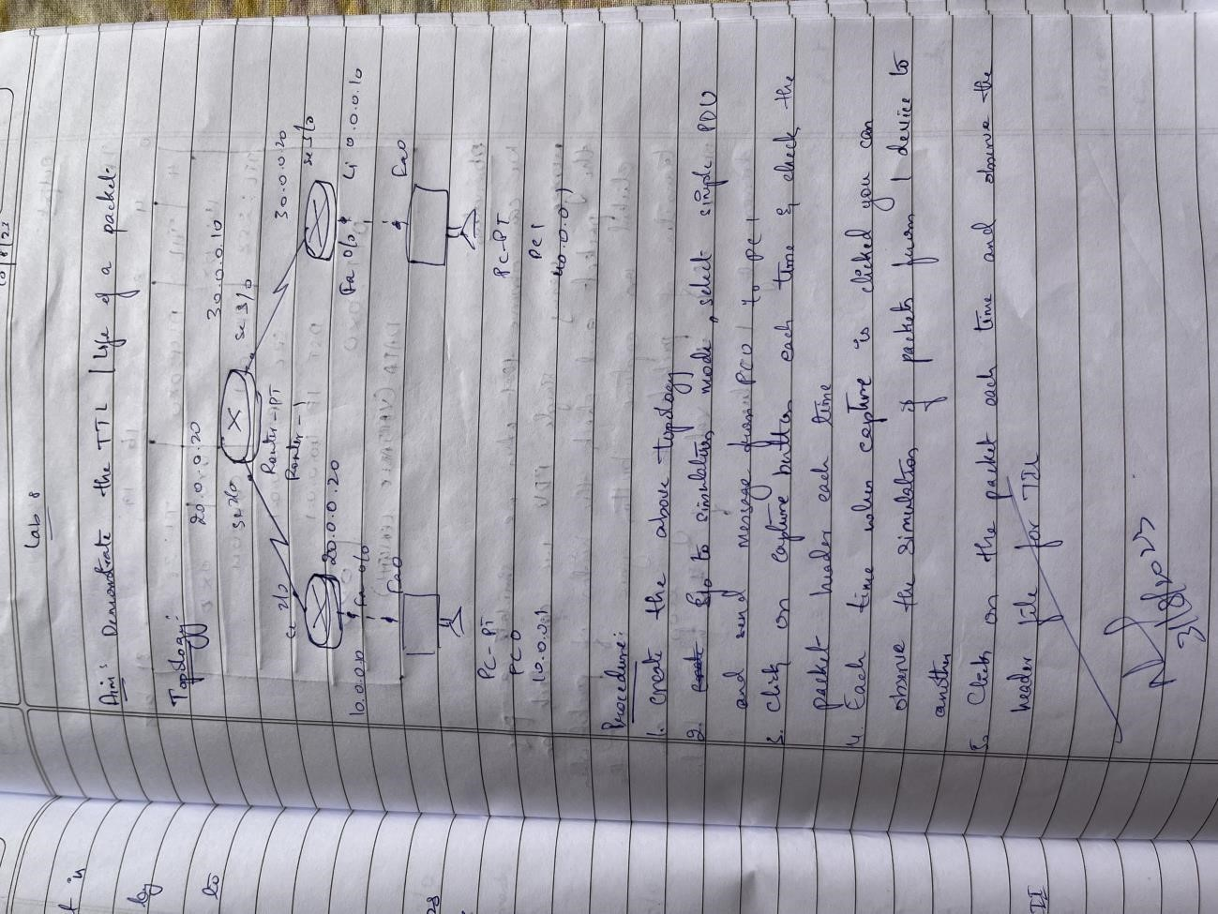

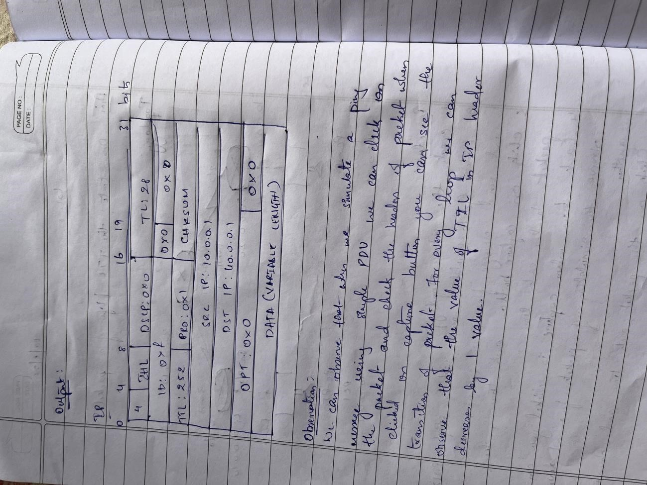

TOPOLOGY:



OUTPUT:

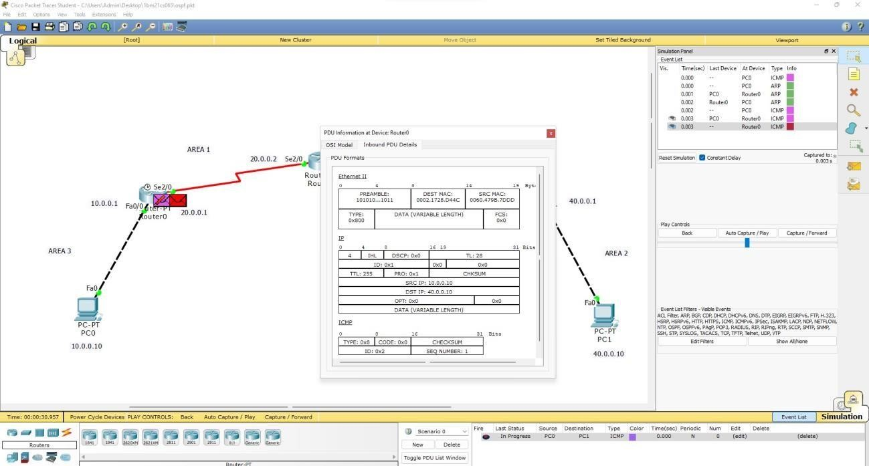

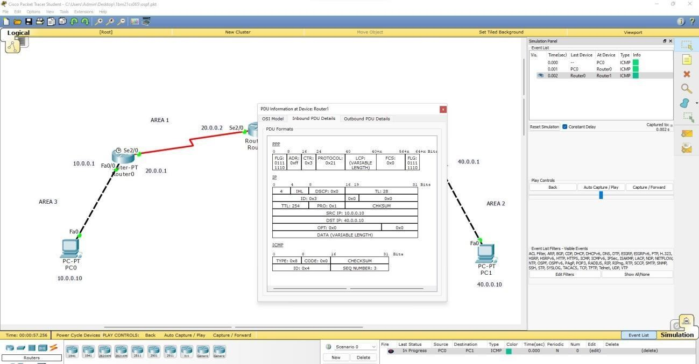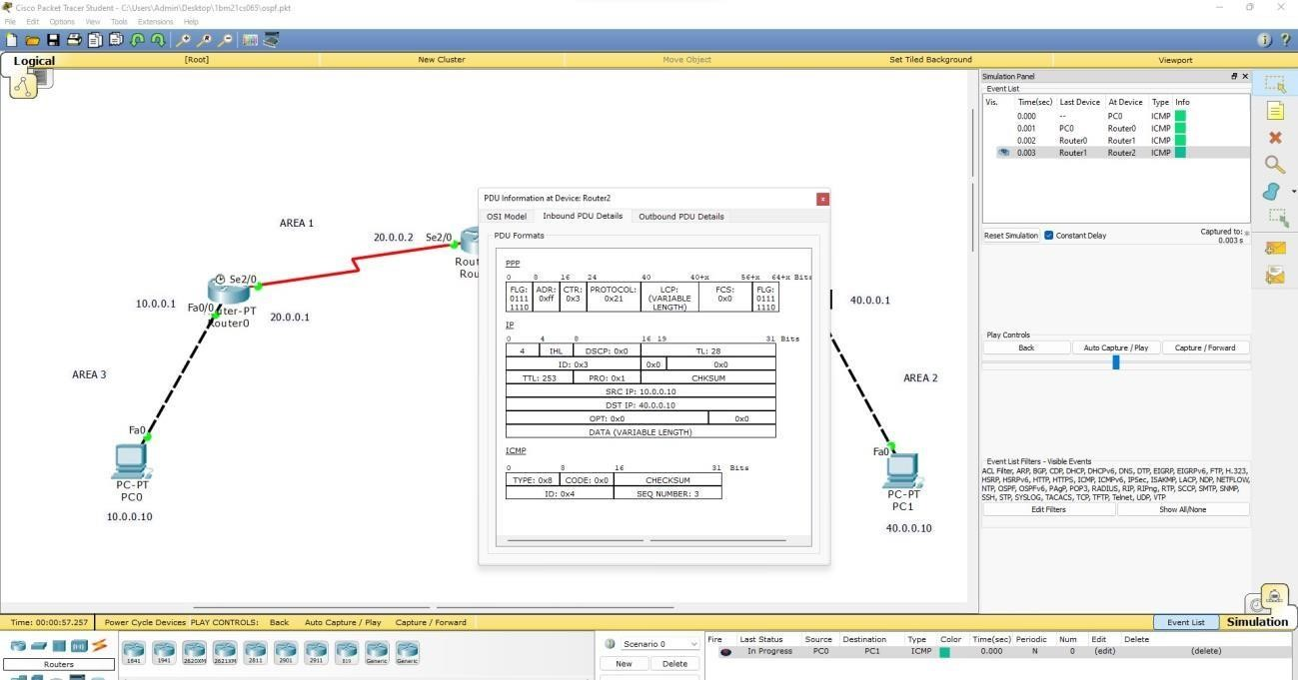

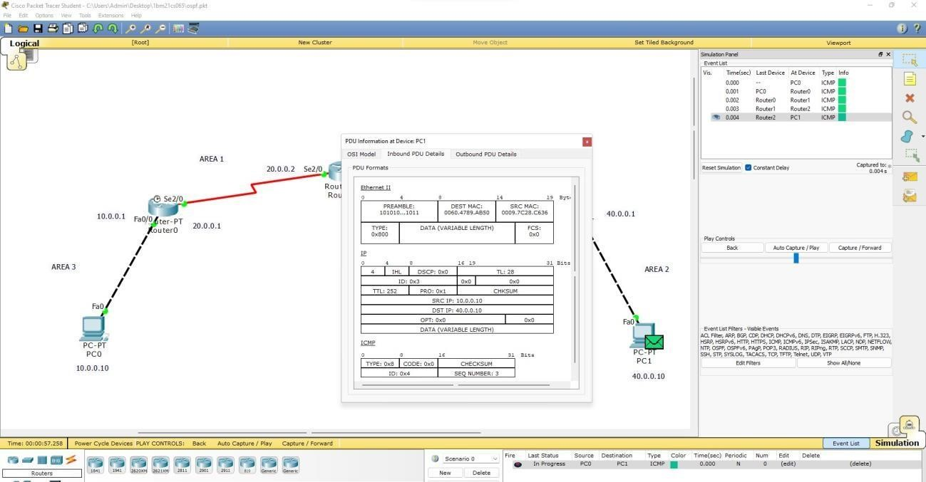

## LAB 11

To construct a WLAN and make the nodes communicate wirelessly OBSERVATION:

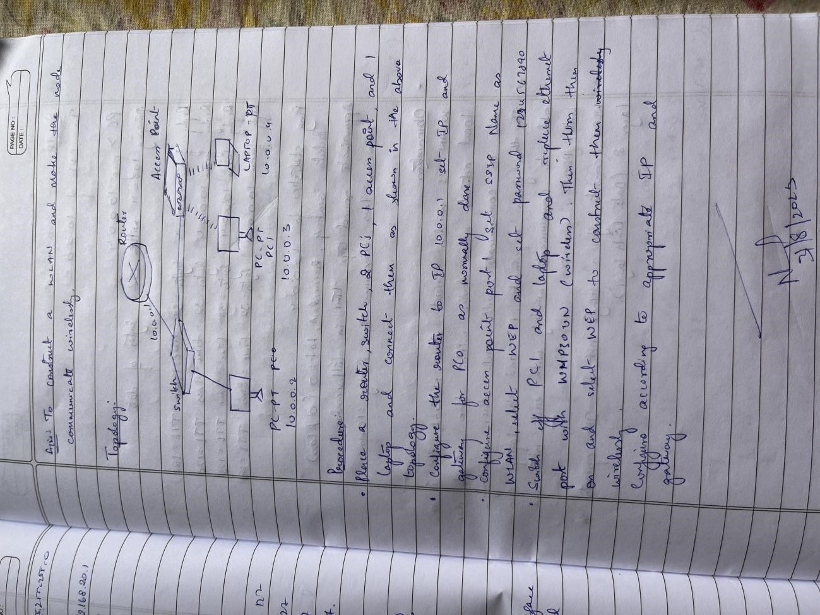

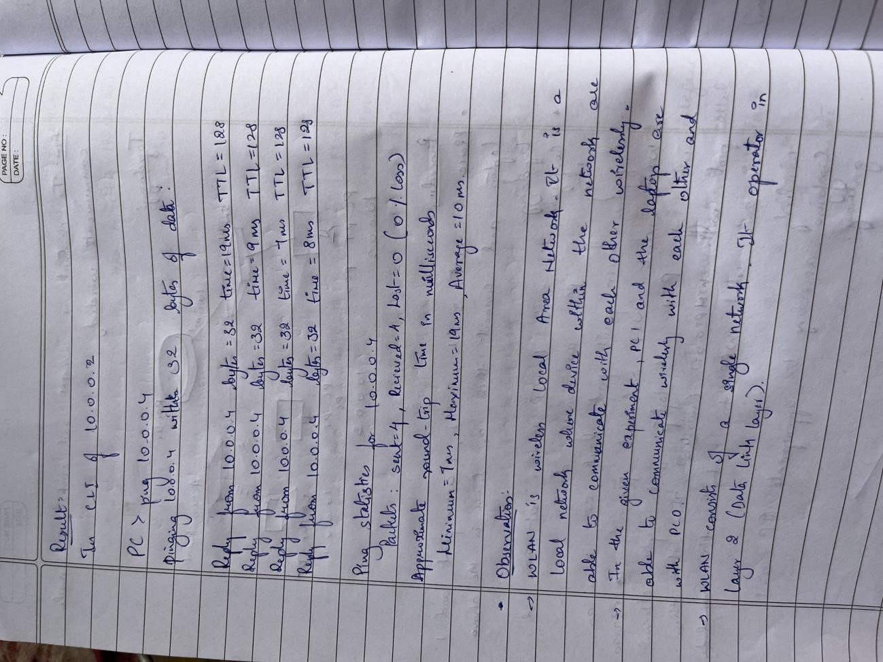

TOPOLOGY:

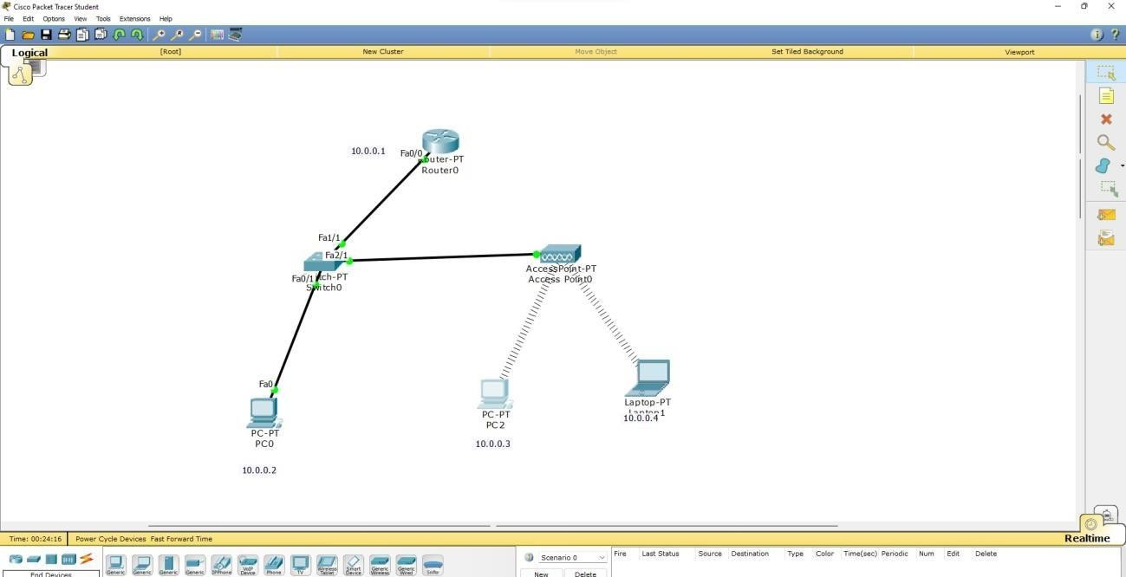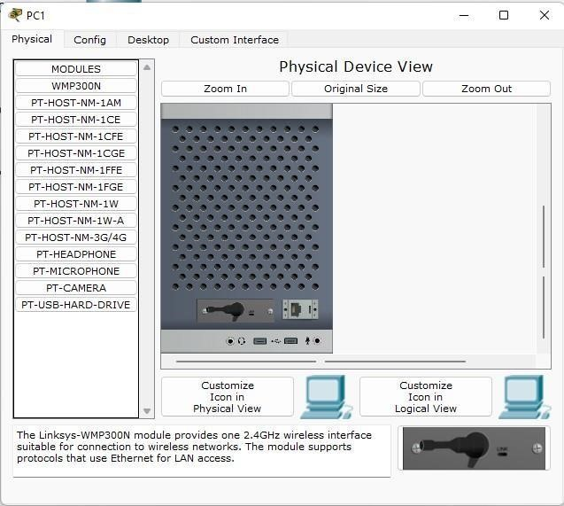

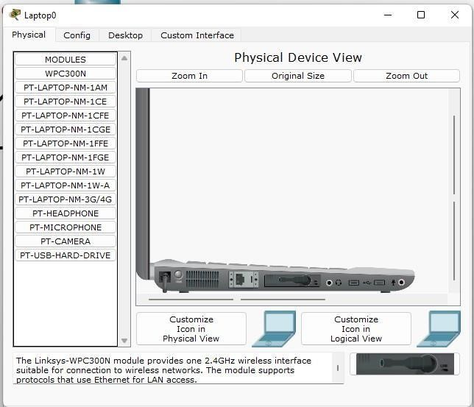

OUTPUT:

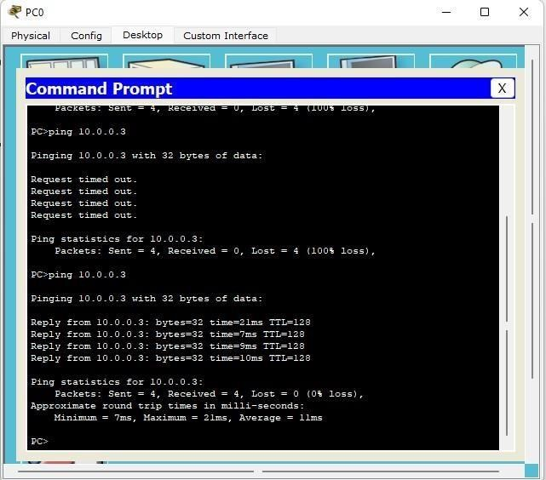

## LAB 12

To understand the operation of TELNET by accessing the router in server room from a PC in IT office.

OBSERVATION:

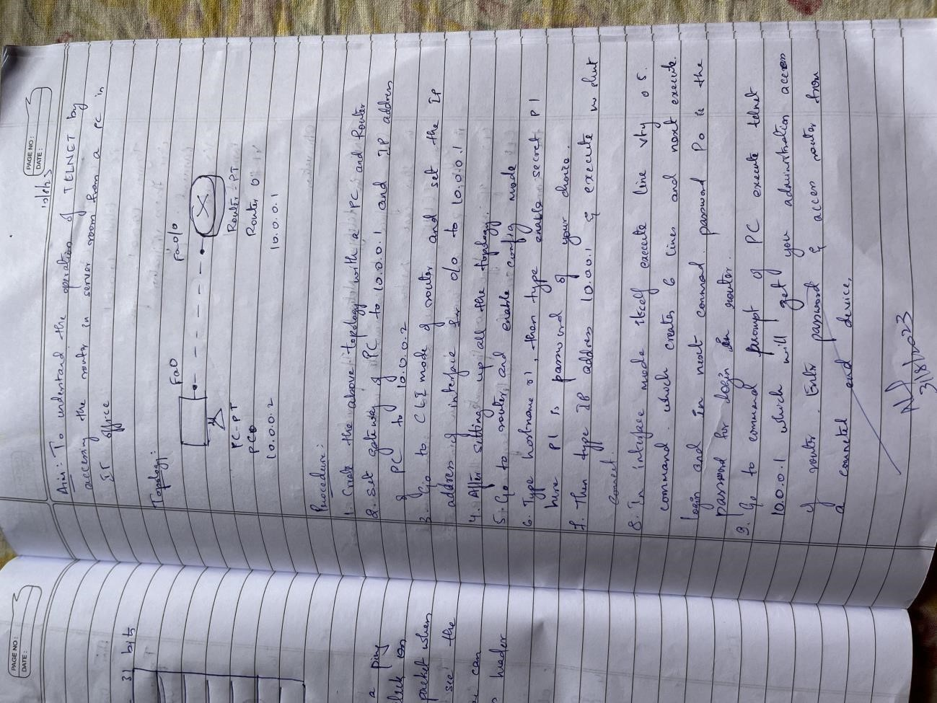

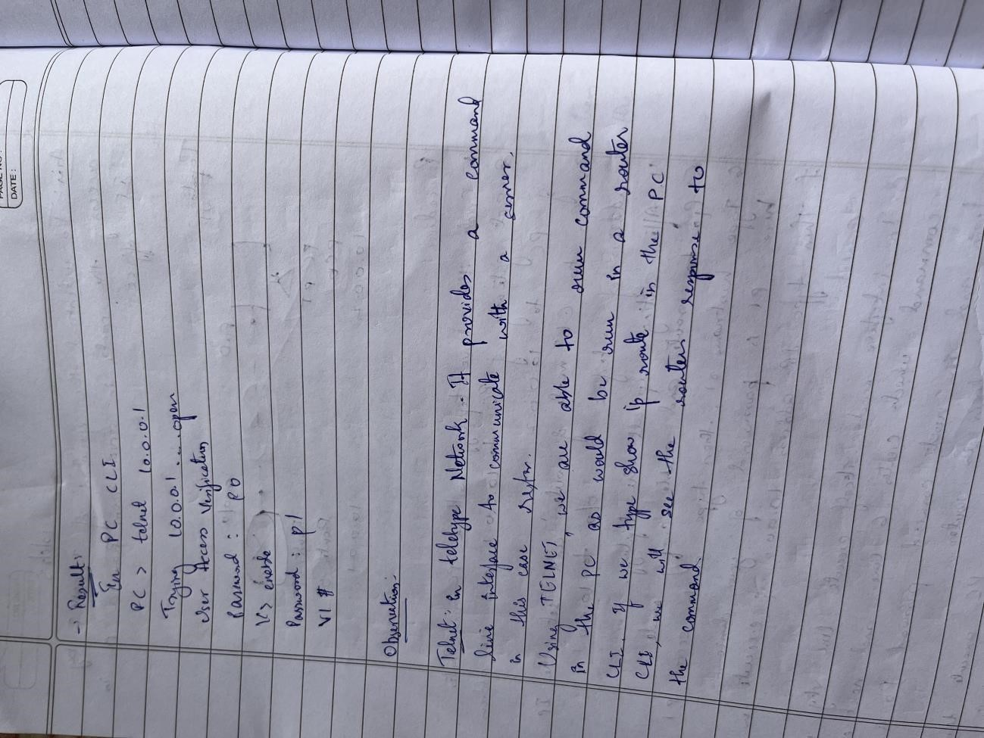

TOPOLOGY:

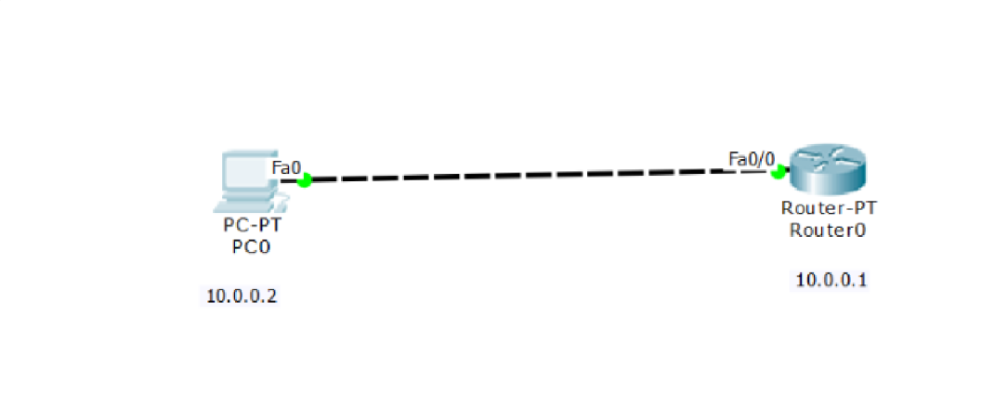

OUTPUT:

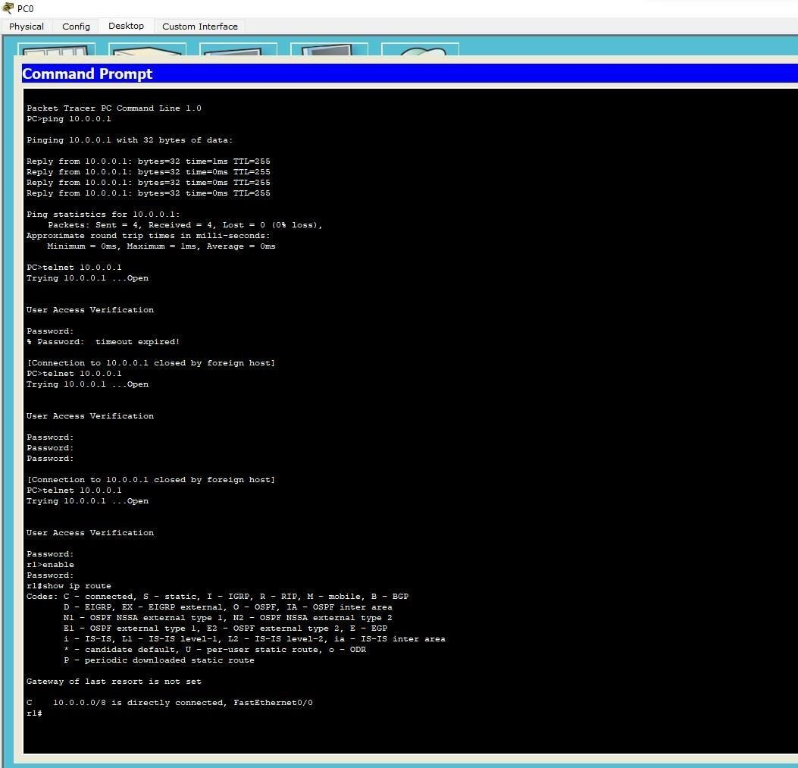

## LAB 13

Write a program for error detecting code using CRC- CCITT (16bits).

CODE:

#include<stdio.h> int arr[17];

void xor(int x[], int y[])

{

int k=0; for(int i=1;i<16;i++)

{ if(x[i]==y[i]) arr[k++]=0;

else arr[i]=1;

}

}

void main()

{ int dd[17],div[33],ze[17],i,k;

printf("Enter the dataword \n"); for(i=0;i<17;i++) scanf("%d",&div[i]); for(i=i;i<33;i++) div[i]=0;

for(i=0;i<17;i++) ze[i]=0; printf("Enter dividend \n"); for(i=0;i<17;i++) scanf("%d",&dd[i]);

i=0; k=0; for(i=i;i<17;i++)

arr[k++]=div[i]; while(i<33)

{ if(arr[0]==0) xor(arr,ze); else

xor(arr,dd); arr[16]=div[i++];

}

k=0; for(i=17;i<33;i++) div[i]=arr[k++]; printf("Codeword: "); for(i=0;i<33;i++) printf("%d",div[i]);

for(i=0;i<17;i++) arr[i]=0; printf("\nAt receiver end

\n");

k=0; for(i=i;i<17;i++)

arr[k++]=div[i];

while(i<33)

{ if(arr[0]==0) xor(arr,ze); else xor(arr,dd); arr[16]=div[i++];

}

k=0;

for(i=17;i<33;i++) div[i]=arr[k++]; printf("Codeword: "); for(i=0;i<33;i++) printf("%d",div[i]);

}

OUTPUT:

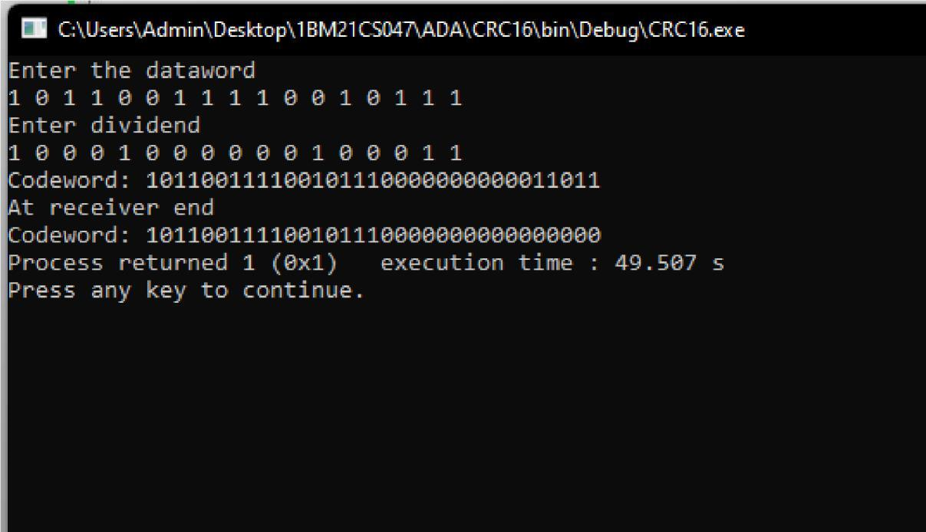

OBSERVATION:

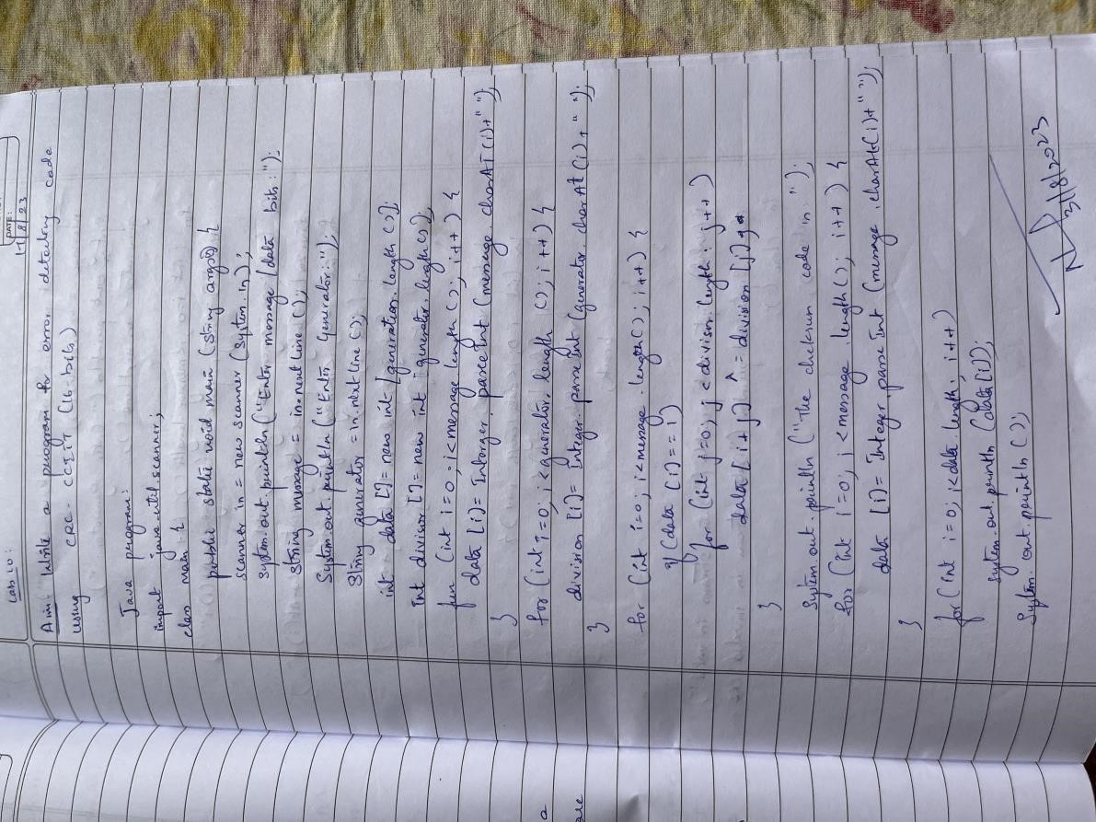

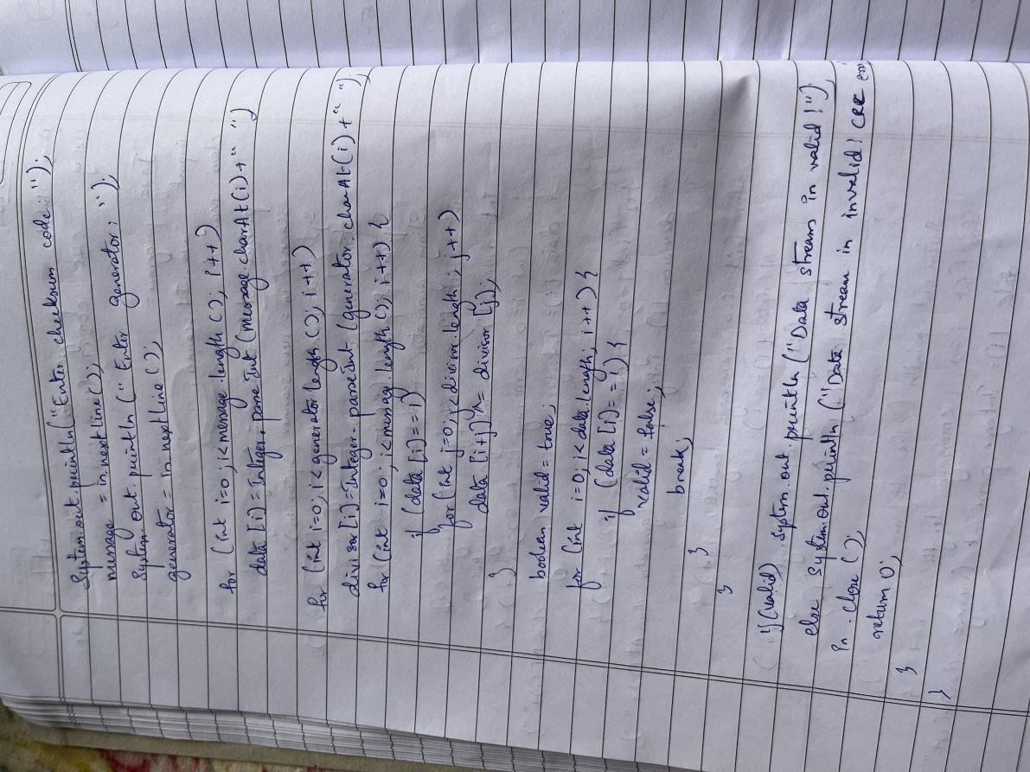

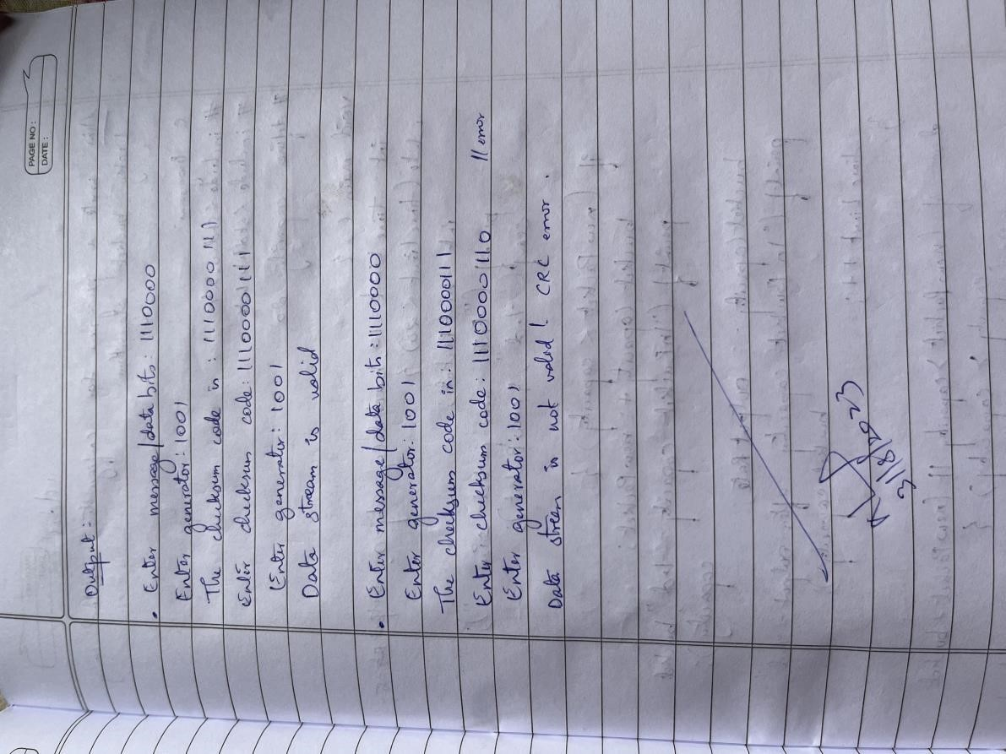

## Lab 14

Write a program for congestion control using Leaky bucket algorithm.

CODE:

#include <stdio.h>

#include <stdlib.h> // Include this for the rand() function int main()

{

int buckets, outlets, k = 1, num, remaining;

printf("Enter Bucket size and outstream size\n"); scanf("%d %d", &buckets, &outlets); remaining = buckets; while (k)

{

num = rand() % 1000; // Generate a random number between 0 and 999 if (num < remaining)

{

remaining = remaining - num; printf("Packet of %d bytes

accepted\n", num); // Added missing

variable

}

else

{

printf("Packet of %d bytes is discarded\n", num);

}

if (buckets - remaining > outlets)

{

remaining += outlets; // Fixed the calculation

}

else remaining = buckets; printf("Remaining

bytes: %d \n", remaining); printf("If you want to stop input, press 0, otherwise, press 1\n"); scanf("%d", &k);

}

while (remaining < buckets) // Fixed the condition

{

if (buckets - remaining > outlets)

{

remaining += outlets; // Fixed the calculation

}

else remaining = buckets;

printf("Remaining bytes: %d \n", remaining);

}

return 0; // Added a return statement to indicate successful completion

}

OUTPUT:

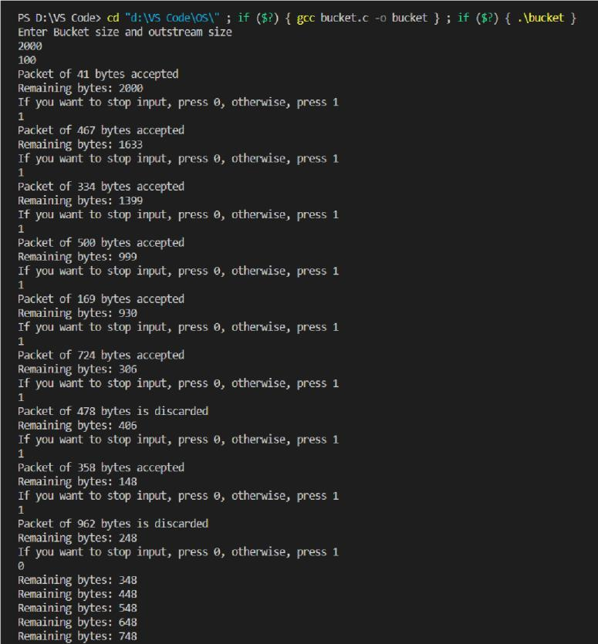

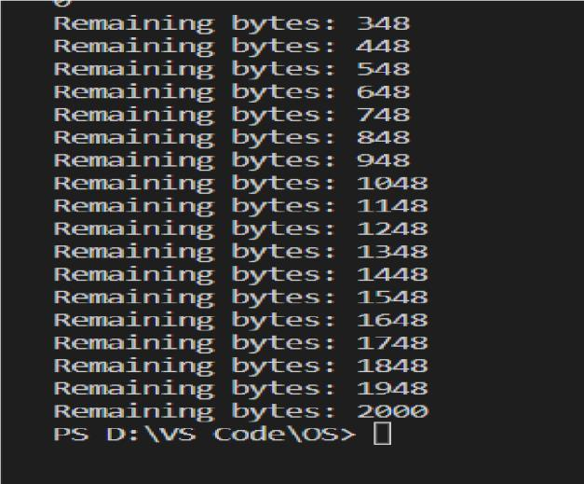

OBSERVATION:

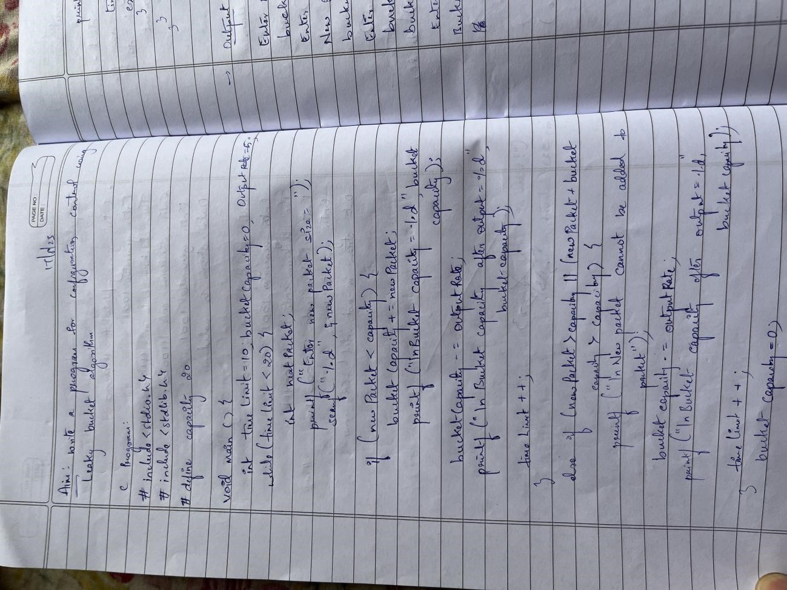

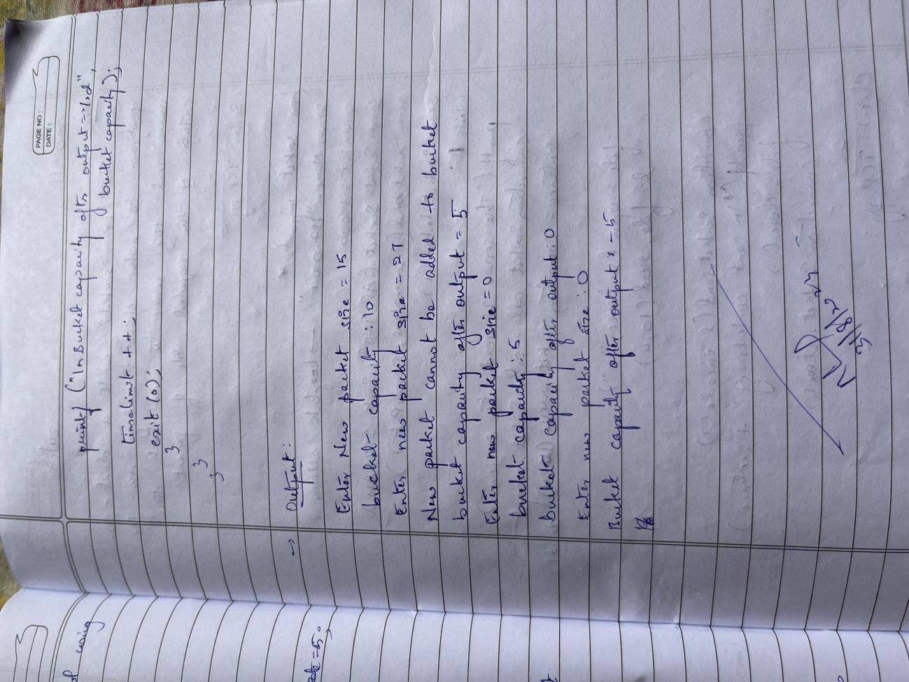

## WEEK15

Using TCP/IP sockets, write a client-server program to make client sending the file name and the server to send back the contents of the requested file if present.

CODE:

ClientTCP.py from socket import * serverName =

“127.0.0.1” serverPort = 12000 clientSocket = socket(AF_INET, SOCK_STREAM) clientSocket.connect((serverName,serverPort)) sentence = input(“\nEnter file name: “) clientSocket.send(sentence.encode()) filecontents =

clientSocket.recv(1024).decode() print (“\nFrom Server:\n”) print(filecontents) clientSocket.close()

ServerTCP.py from socket import * serverName=”127.0.0.1” serverPort = 12000 serverSocket = socket(AF_INET,SOCK_STREAM)

serverSocket.bind((serverName,serverPort)) serverSocket.listen(1) while 1: print

(“The server is ready to receive”)

connectionSocket, addr = serverSocket.accept() sentence =

connectionSocket.recv(1024).decode() file=open(sentence,”r”) l=file.read(1024) connectionSocket.send(l.encode()) print (“\nSent contents of “ + sentence) file.close() connectionSocket.close()

OUTPUT:

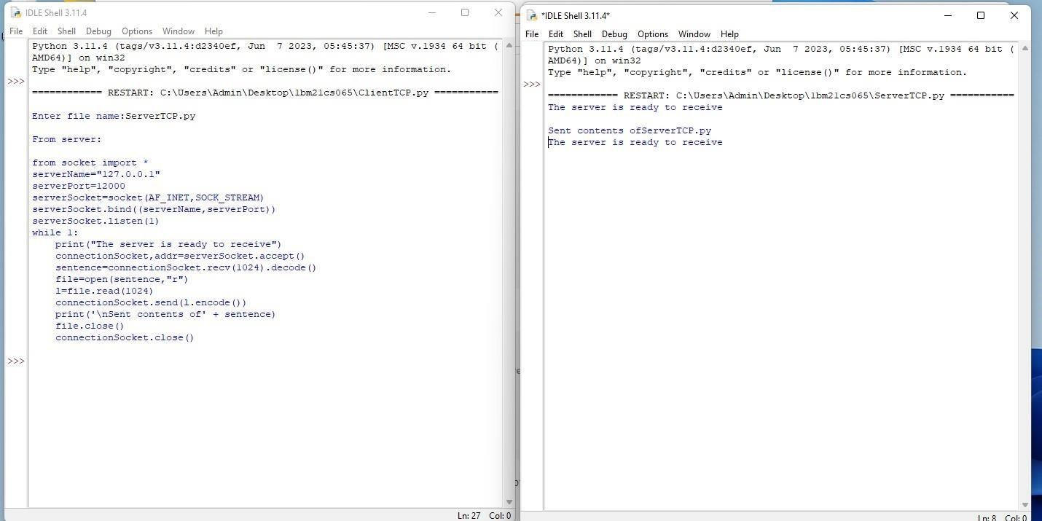

OBSERVATION:

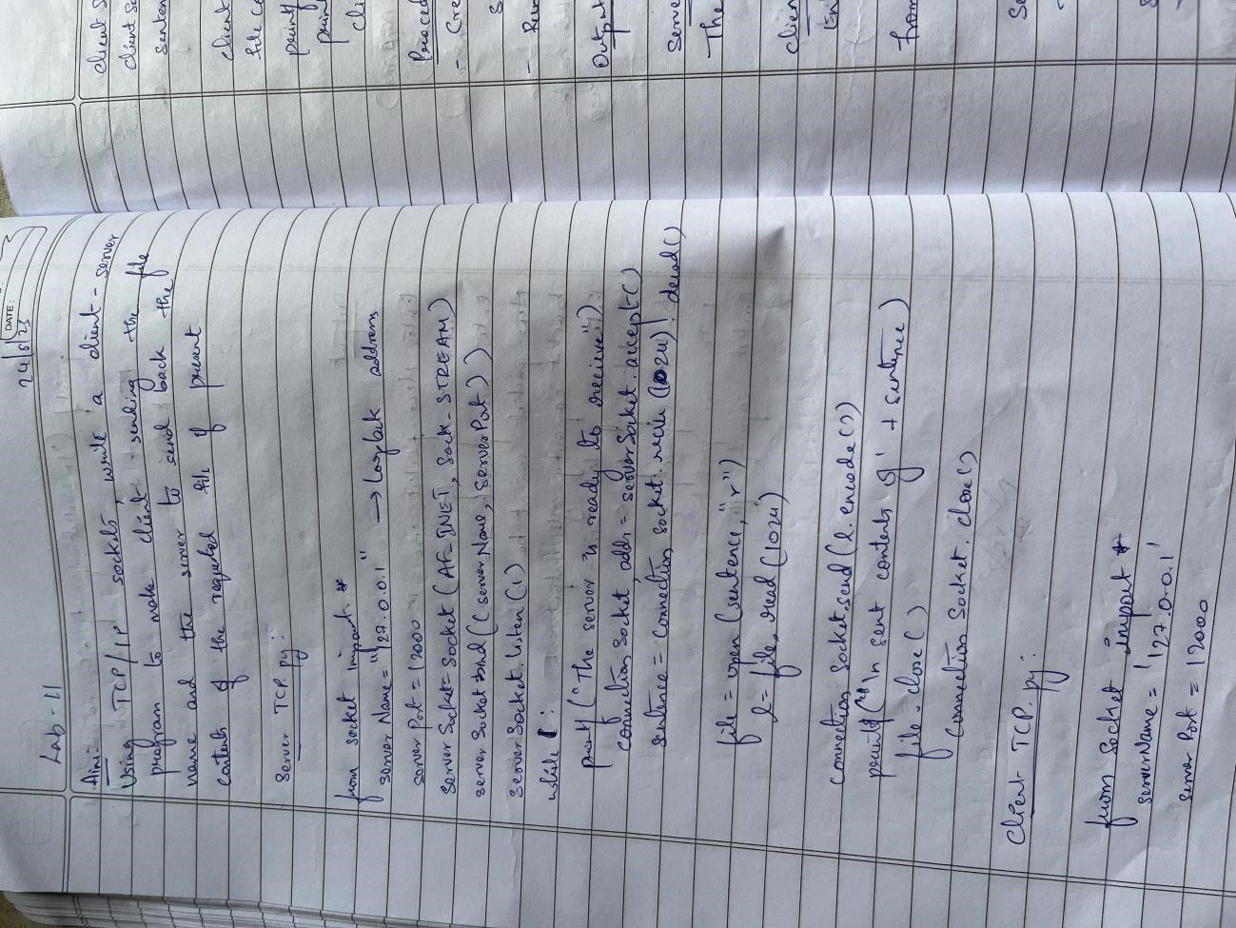

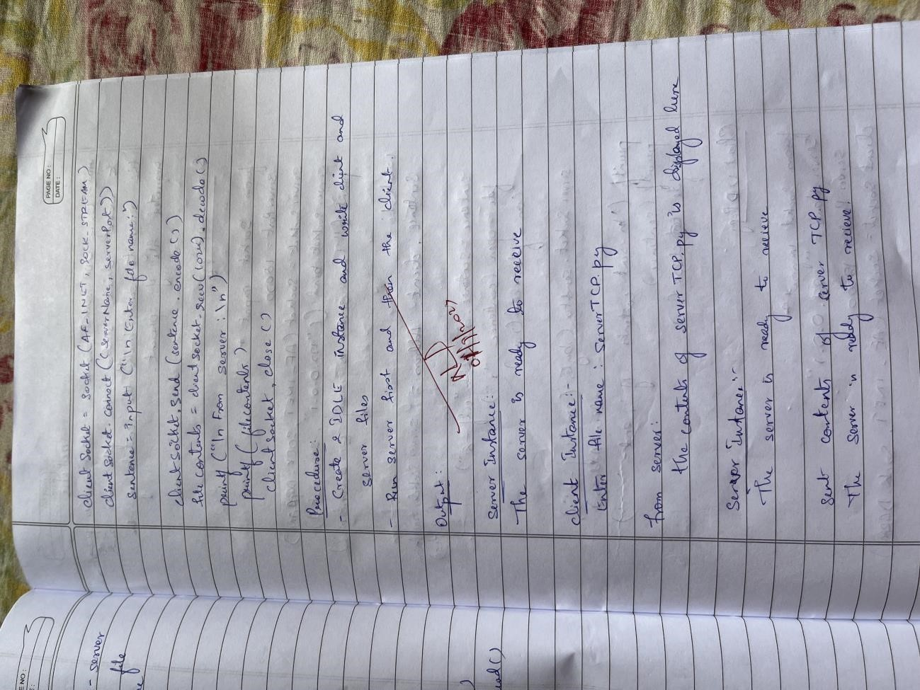

## LAB 16

Using UDP sockets, write a client-server program to make the client send the file name and the server to send back the contents of the requested file if present.

CODE: ClientUDP.py

from socket import * serverName = “127.0.0.1” serverPort = 12000 clientSocket = socket(AF_INET, SOCK_DGRAM) sentence = input(“\nEnter file name: “) clientSocket.sendto(bytes(sentence,”utf8”),(serverName, serverPort)) filecontents,serverAddress = clientSocket.recvfrom(2048) print (“\nReply from Server:\n”) print (filecontents.decode(“utf-8”)) # for i in filecontents: # print(str(i), end = “

”) clientSocket.close() clientSocket.close() ServerUDP.py from socket import * serverPort =

12000

serverSocket = socket(AF_INET, SOCK_DGRAM) serverSocket.bind((“127.0.0.1”, serverPort)) print (“The server is ready to receive”) while 1: sentence, clientAddress = serverSocket.recvfrom(2048) sentence

= sentence.decode(“utf-8”) file=open(sentence,”r”) con=file.read(2048) serverSocket.sendto(bytes(con,”utf-

8”),clientAddress) print (“\nSent contents of “, end = “ “) print

(sentence) # for i in sentence: # print (str(i), end = “ “) file.close()

OUTPUT:

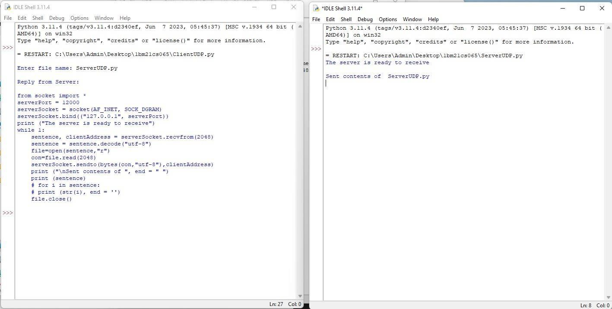

OBSERVATION:

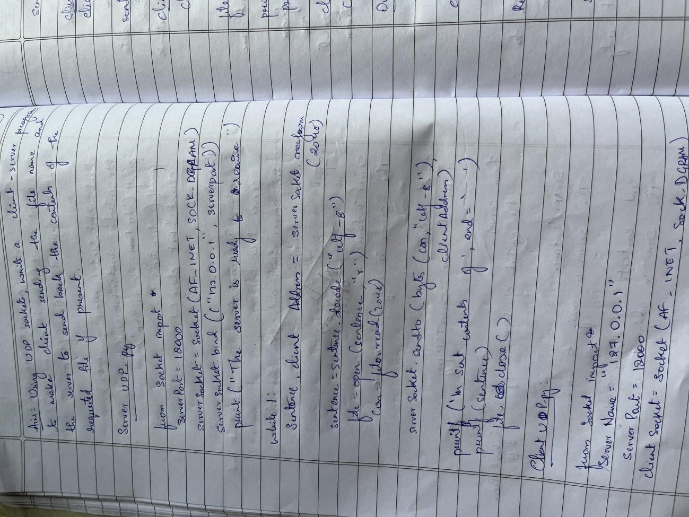

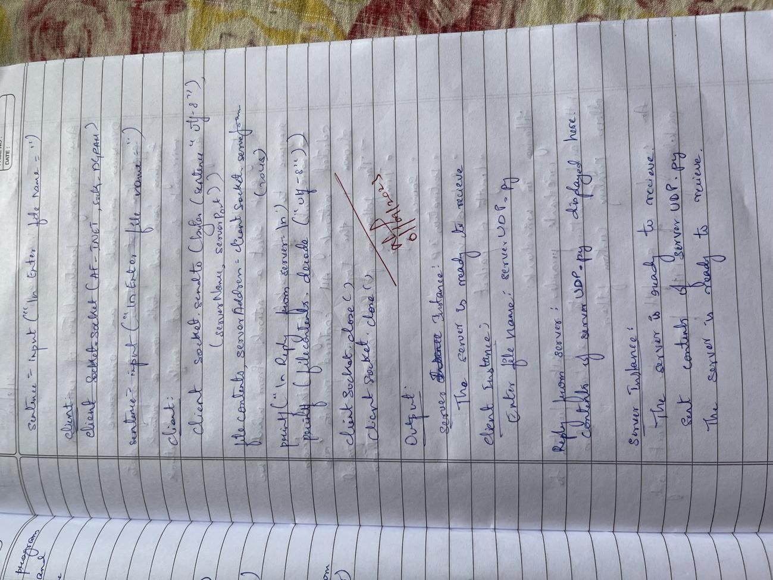

## LAB 17

Tool Exploration -Wireshark OBSERVATION:

